
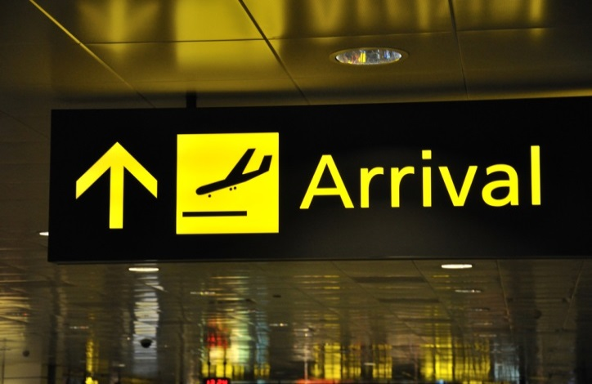


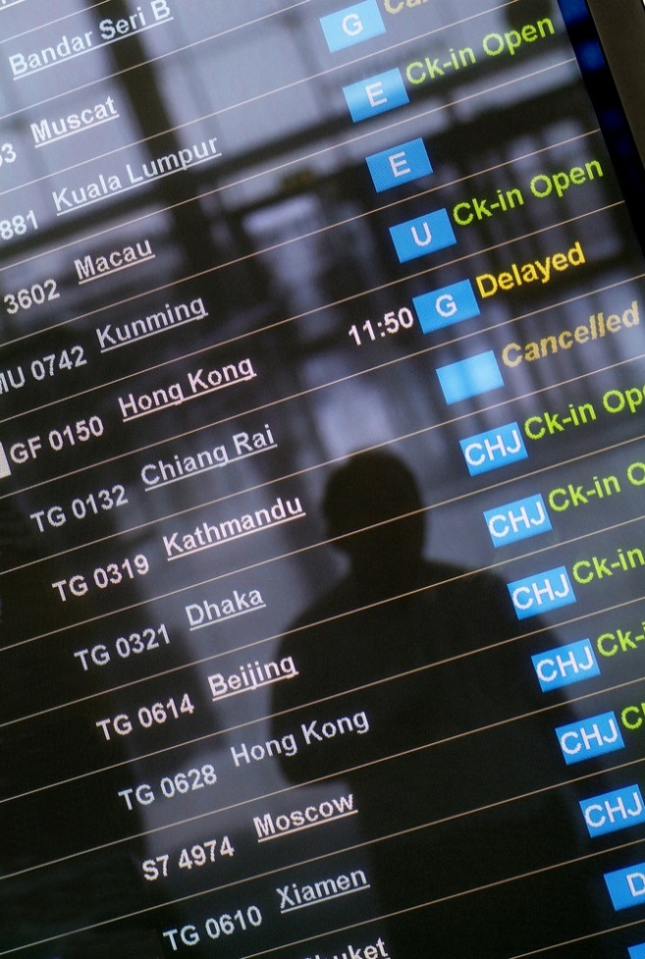




Access and interpret product information
D2.TTA.CL2.01
Trainee Manual

Access and interpret product information
D2.TTA.CL2.01
Trainee Manual





Project Base
William Angliss Institute of TAFE
555 La Trobe Street
Melbourne 3000 Victoria
Telephone: | (03) 9606 2111
Facsimile: | (03) 9670 1330
Acknowledgements
Project Director: | Wayne Crosbie
Project Manager | Jim Irwin
Chief Writer: | Alan Hickman
Subject Writer: | Nick Hyland
Editor: | Jim Irwin
DTP/Production: | Daniel Chee, Mai Vu, Cindy Curran

The Association of Southeast Asian Nations (ASEAN) was established on 8 August 1967. The Member States of the Association are Brunei Darussalam, Cambodia, Indonesia, Lao PDR, Malaysia, Myanmar, Philippines, Singapore, Thailand and Viet Nam.
The ASEAN Secretariat is based in Jakarta, Indonesia.
General Information on ASEAN appears online at the ASEAN Website: www.asean.org.
All text is produced by William Angliss Institute of TAFE for the ASEAN Project on “Toolbox Development for Travel Agencies and Tour Operations Divisions”.
This publication is supported by the Australian Government’s aid program through the ASEAN-Australia Development Cooperation Program Phase II (AADCP II).
Copyright: Association of Southeast Asian Nations (ASEAN) 2015.
All rights reserved.
Disclaimer
Every effort has been made to ensure that this publication is free from errors or omissions. However, you should conduct your own enquiries and seek professional advice before relying on any fact, statement or matter contained in this book. The ASEAN Secretariat and William Angliss Institute of TAFE are not responsible for any injury, loss or damage as a result of material included or omitted from this course. Information in this module is current at the time of publication. Time of publication is indicated in the date stamp at the bottom of each page.
Some images appearing in this resource have been purchased from stock photography suppliers Shutterstock and iStockphoto and other third party copyright owners and as such are non-transferable and non-exclusive. Clip arts, font images and illustrations used are from the Microsoft Office Clip Art and Media Library. Some images have been provided by and are the property of William Angliss Institute.
Additional images have been sourced from Flickr and SXC and are used under Creative Commons licence: http://creativecommons.org/licenses/by/2.0/deed.en

File name: TM_Access and interpret product information_290415





Table of contents
Introduction to trainee manual 1
Unit descriptor 3
Assessment matrix 5
Glossary 7
Element 1: Identify and evaluate sources of product information 9
Element 2: Access product information 41
Element 3: Interpret product information 73
Element 4: Provide product information 91
Presentation of written work 133
Recommended reading 135
Trainee evaluation sheet 137
Trainee self-assessment checklist 139

Introduction to trainee manual

To the Trainee
Congratulations on joining this course. This Trainee Manual is one part of a ‘toolbox’ which is a resource provided to trainees, trainers and assessors to help you become competent in various areas of your work.
The ‘toolbox’ consists of three elements:
- A Trainee Manual for you to read and study at home or in class
- A Trainer Guide with Power Point slides to help your Trainer explain the content of the training material and provide class activities to help with practice
- An Assessment Manual which provides your Assessor with oral and written questions and other assessment tasks to establish whether or not you have achieved competency.
The first thing you may notice is that this training program and the information you find in the Trainee Manual seems different to the textbooks you have used previously. This is because the method of instruction and examination is different. The method used is called Competency based training (CBT) and Competency based assessment (CBA). CBT and CBA is the training and assessment system chosen by ASEAN (Association of South-East Asian Nations) to train people to work in the tourism and hospitality industry throughout all the ASEAN member states.
What is the CBT and CBA system and why has it been adopted by ASEAN?
CBT is a way of training that concentrates on what a worker can do or is required to do at work. The aim is of the training is to enable trainees to perform tasks and duties at a standard expected by employers. CBT seeks to develop the skills, knowledge and attitudes (or recognise the ones the trainee already possesses) to achieve the required competency standard. ASEAN has adopted the CBT/CBA training system as it is able to produce the type of worker that industry is looking for and this therefore increases trainees’ chances of obtaining employment.
CBA involves collecting evidence and making a judgement of the extent to which a worker can perform his/her duties at the required competency standard. Where a trainee can already demonstrate a degree of competency, either due to prior training or work experience, a process of ‘Recognition of Prior Learning’ (RPL) is available to trainees to recognise this. Please speak to your trainer about RPL if you think this applies to you.
What is a competency standard?
Competency standards are descriptions of the skills and knowledge required to perform a task or activity at the level of a required standard.
242 competency standards for the tourism and hospitality industries throughout the ASEAN region have been developed to cover all the knowledge, skills and attitudes required to work in the following occupational areas:
- Housekeeping
- Food Production
- Food and Beverage Service
- Front Office
- Travel Agencies
- Tour Operations.
All of these competency standards are available for you to look at. In fact you will find a summary of each one at the beginning of each Trainee Manual under the heading ‘Unit Descriptor’. The unit descriptor describes the content of the unit you will be studying in the Trainee Manual and provides a table of contents which are divided up into ‘Elements’ and ‘Performance Criteria”. An element is a description of one aspect of what has to be achieved in the workplace. The ‘Performance Criteria’ below each element details the level of performance that needs to be demonstrated to be declared competent.
There are other components of the competency standard:
- Unit Title: statement about what is to be done in the workplace
- Unit Number: unique number identifying the particular competency
- Nominal hours: number of classroom or practical hours usually needed to complete the competency. We call them ‘nominal’ hours because they can vary e.g. sometimes it will take an individual less time to complete a unit of competency because he/she has prior knowledge or work experience in that area.
The final heading you will see before you start reading the Trainee Manual is the ‘Assessment Matrix’. Competency based assessment requires trainees to be assessed in at least 2 – 3 different ways, one of which must be practical. This section outlines three ways assessment can be carried out and includes work projects, written questions and oral questions. The matrix is designed to show you which performance criteria will be assessed and how they will be assessed. Your trainer and/or assessor may also use other assessment methods including ‘Observation Checklist’ and ‘Third Party Statement’. An observation checklist is a way of recording how you perform at work and a third party statement is a statement by a supervisor or employer about the degree of competence they believe you have achieved. This can be based on observing your workplace performance, inspecting your work or gaining feedback from fellow workers.
Your trainer and/or assessor may use other methods to assess you such as:
- Journals
- Oral presentations
- Role plays
- Log books
- Group projects
- Practical demonstrations.
Remember your trainer is there to help you succeed and become competent. Please feel free to ask him or her for more explanation of what you have just read and of what is expected from you and best wishes for your future studies and future career in tourism and hospitality.

Unit descriptor
Access and interpret product information
This unit deals with the skills and knowledge required to Access and interpret product information in a range of settings within the travel industries workplace context.
Unit Code:
D2.TTA.CL2.01
Nominal Hours:
40

Element 1: Identify and evaluate sources of product information
Performance Criteria
1.1 List potential sources of product information
1.2 Determine usefulness of product information sources
1.3 Identify items that may contain product information

Element 2: Access product information
Performance Criteria
2.1 Select appropriate sources of product information
2.2 Register to receive and/or access product information
2.3 Visit suppliers and other sources to talk with sales staff and obtain items that may contain product information
2.4 Access selected internal databases and internal business systems
2.5 Access external sources of product information

Element 3: Interpret product information
Performance Criteria
3.1 Identify specific sales needs that form the basis for the search for product information
3.2 Read items that may contain product information
3.3 Integrate sourced product information with identified client needs and/or preferences

Element 4: Provide product information
Performance Criteria
4.1 Interpret industry terminology
4.2 Pass on general information relating to products and services
4.3 Explain specific details about product and services

Assessment matrix
Showing mapping of Performance Criteria against Work Projects, Written Questions and Oral Questions
The Assessment Matrix indicates three of the most common assessment activities your Assessor may use to assess your understanding of the content of this manual and your performance - Work Projects, Written Questions and Oral Questions. It also indicates where you can find the subject content related to these assessment activities in the Trainee Manual (i.e. under which element or performance criteria). As explained in the Introduction, however, the assessors are free to choose which assessment activities are most suitable to best capture evidence of competency as they deem appropriate for individual students.
 |  |  | Work Projects | Written Questions | Oral Questions
Element 1: Identify and evaluate sources of product information
1.1 | List potential sources of product information |  | 1.1 | 1,2,3 | 1
1.2 | Determine usefulness of product information sources |  | 1.2 | 4,5 | 2
1.3 | Identify items that may contain product information |  | 1.3 | 6,7 | 3
Element 2: Access product information
2.1 |  | Select appropriate sources of product information | 2.1 | 8,9 | 4
2.2 |  | Register to receive and/or access product information | 2.2 | 10,11,12 | 5
2.3 |  | Visit suppliers and other sources to talk with sales staff and obtain items that may contain product information | 2.3 | 12,13 | 6
2.4 |  | Access selected internal databases and internal business systems | 2.4 | 14,15,16 | 7
2.5 |  | Access external sources of product information | 2.5 | 17 | 8
Element 3: Interpret product information
3.1 | Identify specific sales needs that form the basis for the search for product information |  | 3.1 | 18 | 9
3.2 | Read items that may contain product information |  | 3.2 | 19,20,21 | 10
3.3 | Integrate sourced product information with identified client needs and/or preferences |  | 3.3 | 22,23 | 11
Element 4: Provide product information
4.1 |  | Interpret industry terminology | 4.1 | 24,25,26 | 12
4.2 |  | Pass on general information relating to products and services | 4.2 | 27,28 | 13
4.3 |  | Explain specific details about product and services | 4.3 | 29,30 | 14

Glossary
Term | Explanation
Analyse | To examine in detail in order to discover meaning, essential features
Assumption | A calculated guess
Auxiliary products and services | Any product or service that supports the travel experience including travel insurance. currency and banking, visas, merchandise etc
Compliance | To meet the requirements of
CRS | Computer Reservations system
Customer | Any person who is paying for a product or service provided
Data | Individual facts, statistics, or items of information
Database | A collection of information that is organised so that it can easily be accessed, managed, and updated
Feedback | A reaction or response
Findings | Conclusions based on calculated thought
GDS | Global Distribution System
GPS | Global Positioning System
Inbound Tour Wholesaler | Packages products to form a trip for an overseas market travelling to a specific country
Information systems | Software package that is used to collect data and translate it into useful information
Initiatives | An introductory act or step; leading action
Interpret | To give or provide the meaning of; explain; explicate
Issues | A topic of importance
Itinerary | A planned route or journey
Objectives | Something that one's efforts or actions are intended to attain or accomplish; purpose; goal; target
Outbound Tour Wholesaler | Negotiates product from International Suppliers for clients in a specific travelling to an international destination
Phonetic alphabet | A set of words used to stand for the letters of an alphabet in oral communication
Policy | A rule or statement
Procedure | A step by step instruction on how a specific incident or activity should be conducted
Product information inventory | A database used for storing and administering all types of product information data
Product | Anything that can be offered to a market that might satisfy a want or need
Quotation | A document stating all requested information relating to a travel product and service including inclusions, costs and considerations
Service | Intangible offering that adds to the travel experience
Statistics | The study of the collection, analysis, interpretation, presentation, and organisation of data
Testimonial | Formal statement testifying the characteristics of an organisation
Tour operator | Organises sightseeing tours and accommodation in a particular destination or region
Tourism board | Coordinate the efforts of hotels, airlines and travel agents to develop the tourism industry of the country

Element 1:
Identify and evaluate sources of product information

1.1 List potential sources of product information

Introduction
The tourism industry is one of the largest industries in the world and for many countries is its major economy and employer. Tourism has become a very significant global activity and as disposable income and the ease of travel continue to prosper, so will the industry.

Industry knowledge is a vital pre-requisite for effective performance within the industry.
There are many sources of information that can assist you. Some of these sources are generic in nature and others are specific to the industry.
The idea of obtaining product knowledge is so that you can use it for:
- Your benefit
- The benefit of the venue
- The ultimate benefit of the customers.
Product and service knowledge
Developing and maintaining product knowledge is a very important element of providing excellent levels of customer service in the tourism industry.

All tourism establishments will be expected to provide accurate product information to their customers.
The level and nature of the product knowledge will differ between customers, however all tourism staff must have a wide range of product knowledge at their disposal to meet the informational needs of their customers.
Whilst no-one expects everyone to know everything there is to know about all the tourism options that may exist, all staff must have at least substantial general tourism knowledge but also know where to source information in a timely manner.


There are endless sources of product information that can be collected, analysed and used by a travel and tourism organisation for the benefit of the organisation itself or to assist customers with potential travel plans.
This section will explore:
- Common types of products and services in the tourism industry
- Sources of product and services information
- Identify types of product and services information.

Summary of tourism products and services
Products and services can be divided into the main areas of air, land, sea and auxiliary.
- Air – air travel and associated taxes
- Land – anything that is not air travel or a cruise
- Sea – cruises, ferries etc
- Auxiliary – any product or service that supports the travel experience.
The area generally termed ‘land arrangements’ covers an array of products and services which fall into the following main areas:
- Accommodation
- Transfers
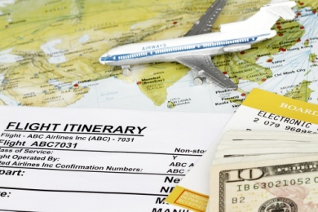
- Transportation – rail, ferry, car and van hire
- Tours
- Attractions, activities and entertainment.
Auxiliary products and services encompass:
- Travel Insurance
- Currency and banking
- Visas
- Merchandise
- Airport parking.

Tourism industry organisations
When compiling product information for your 'product knowledge' data bases, it is essential to identify the different types of businesses in which your potential customers may use.

Whilst gathering information from all tourism operators is impossible and impractical, identifying commonly used tourism providers will enable you to gather information relating to the products and services they provide.
In addition it enables you to ensure that the information that you have gathered is accurate and up to date.
Depending on the types of tourism offerings provided by your organisation possible businesses in which you may seek product information from includes, but not limited to:
- Airlines
- Other travel suppliers
- Suppliers
- Accommodation
- Attractions and theme parks
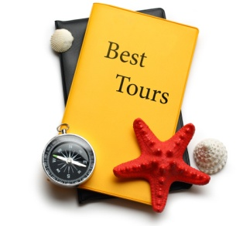
- Tour operators
- Inbound Tour Wholesaler
- Outbound Tour Wholesale
- Retail Travel Agents
- Local, regional and National information services
- Meetings and Events
- Corporate Agents
- Ministries of Tourism
- Tourism boards
- Industry authorities
- Industry associations.
The breakdown of businesses identified in the categories above will be identified in more detail in this section.
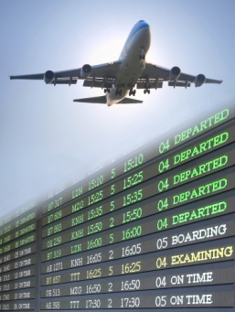
Airlines
Airlines own the planes and sell seats to all sectors in the travel industry. They do this via a Computer Reservations system (CRS) such as Galileo, Sabre and Amadeus.
They also sell seats via the Internet and via the phone to the public. Airlines negotiate rates with Retail Agents, Wholesalers, and Corporate Agents who then take a commission from the airline sale. Some Airlines have a Wholesale division which sells directly to Retail agents.
Other travel suppliers
These include but are not limited to:
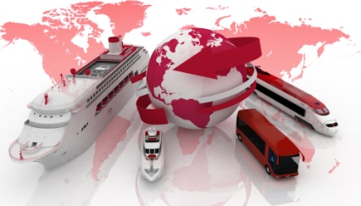
- Cruise operators
- Railway operators
- Bus lines
- Car rental businesses
- Limousine hire
- Taxis.
Suppliers and providers of support and ancillary services
This includes:

- Travel insurance providers
- Finance providers
- Currency exchange
- Conference and similar venues
- Interpreters.
Accommodation
This sector includes but not limited to:
- Hotels and motels
- Guest houses

- Bed and breakfasts
- Caravan parks and camping grounds
- Resorts
- Time share properties
- Apartments, villas and cottages
- Conference and exhibition centres.
Attractions and Theme Parks
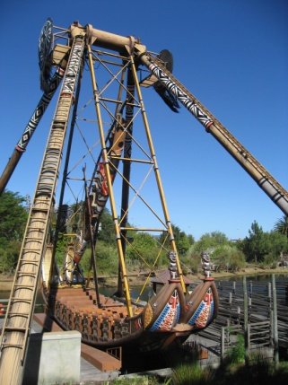
This sector includes but not limited to:
- Museums and galleries
- National parks, wildlife parks and gardens
- Theme parks
- Heritage sites and centres
- Sport and activity centres
- Aquarium and zoos.
Tour Operators
A tour operator typically organises sightseeing tours and accommodation in a particular destination or region. They act as a middle person between the Wholesaler and the Principal or Supplier of the product
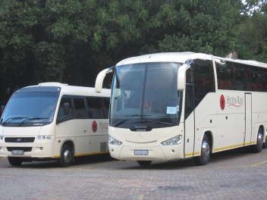
Examples of businesses include Trafalgar Tours and Contiki.
Visit:
- www.trafalgartours.com
- www.contiki.com
Inbound Tour Wholesaler
An Inbound Tour Wholesaler packages products to form a trip for an overseas market travelling to a specific country.
Outbound Tour Wholesaler

An Outbound Tour Wholesaler negotiates product from International Suppliers for clients in a specific travelling to an international destination. They approach airlines, hotel, local tour operators, cruise companies, car rental companies and rail companies to obtain wholesale rates which are then on-sold to the public via the Retail Travel Agents
Examples of businesses include Tempo Holidays, Peregrine Adventures and Creative.
Visit:
- www.tempoholidays.com
- www.peregrineadventures.com
- www.creativeholidays.com
Retail Travel Agents

A Retail Travel agent is the go-between between the client and the Wholesaler. It is the Retail agent who obtains all the relevant details from a client to enable them to make a booking through a Wholesaler. All this information is then finalised and paid for to the Wholesaler. Both the Retail agent and the Wholesaler make commission from the booking.
Examples of these businesses include: Flight Centre, STA and American Express
Visit:
- www.harveyworld.com
- www.flightcentre.com
- www.statravel.com

Local, regional and national information services
These information services exist to assist the public and Travel agents in obtaining information on a particular region from the experts. This can be at a local, regional or national level.
These bureaus can be independent bodies or come under the support and direction of the respective Ministries of Tourism, which will be identified later.

These bureaus take calls from Travel agents as well as the public to help in promoting their region. They have wholesale divisions and all staff are experts in their area.
All these locally based Tourist bureaus have a fantastic website with a wealth of information and products to extend one’s knowledge.
At a regional level there may be Information Centres, which provides a local booking service for accommodation in the area. They also provide pamphlets on local attractions which inform visitors of points of interest in the area.
Meetings and Events
This sector has been one of the fastest growing within the tourism and hospitality industry.
These companies organise meetings, conferences and major events by booking flights, accommodation, tours and the meeting facilities for their Client and their guests.

Large Corporate Companies have a separate department set up specifically to cater for the conference and event market. An example of this type of Company is HRG (Hogg Robinson Group) which is a UK based company specialising in corporate travel and having a division specifically setup for conference and event bookings. There are also independent companies that only specialise in Meetings and Events, such as The Event Factory and C1 Events.

Ministries of Tourism
Each country within the ASEAN region will have dedicated government ministry specifically focused on the tourism industry. Their role is to regulate and manage the industry.
A Ministry of Tourism is normally responsible for the formulation of national policies and programmes and for the co-ordination of activities of various governments and the private Sector for the development and promotion of tourism in the country.
The Ministry may co-ordinate special initiatives including:
- Selecting and managing heritage sites
- Dedication and allocation of government funding to tourism initiatives
- Providing information on news laws and regulations
- Establishing service excellence awards
- Publishing and managing tenders for tourism projects.
The ASEAN region, whilst working collectively to achieve a primary purpose of attracting tourism to the region as a whole, each participating government will also have their own websites and departments in which to collect information. They have been identified below.

BRUNEI
Tourism Development Division
Ministry of Industry and Primary Resources
Jln. Menteri Besar, Bandar Seri Begawan, Brunei Darussalam
Tel. (673-2) 382822 Fax. (673-2) 382824
Email: info@bruneitourism.travel
Website: http://www.bruneitourism.travel/
CAMBODIA
Ministry of Tourism
3, Preah Monivong Blvd, Phnom Penh, Cambodia
Tel. (855-23) 213911 Fax. (855-23) 426107/217503
Email: dgpro@camnet.com.kh
Website: http://www.tourismcambodia.com/
INDONESIA
Ministry of Culture and Tourism
Jl. Medan Merdeka Barat 17, Jakarta 10110, Indonesia
Tel. (62-21)3838157 Fax. (62-21) 3849715
Website:
http://www.budpar.go.id
http://www.my-indonesia.info

LAOS
National Tourism Authority of Lao P.D.R.
Lane Xang Avenue, P.O. Box 3556, Vientiane, Lao P.D.R.
Tel. (856-21) 212248 Fax. (856-21) 212769/2127910
Website: http://www.tourismlaos.gov.la/
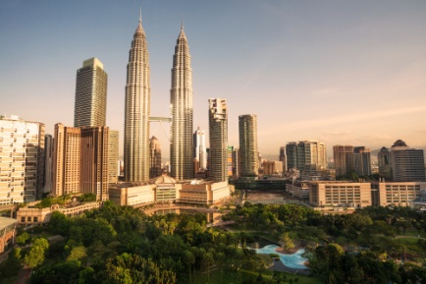
MALAYSIA
Ministry of Tourism
Menara Dato' Onn
Putra World Trade Center, 50480, Kuala Lumpur, Malaysia
Tel. (603) 2693 5188 Fax. (603) 269 0207/2693 0884
Email: tourism@tourism.gov.my
Website: http://www.tourism.gov.my
MYANMAR
Ministry of Hotels and Tourism
No. 77-91, Sule Pagoda Road, Yangon, Myanmar
Tel. (95-1) 285689 Fax. (95-1) 289588/254417
Email: dht.mht@myanmar.com.mm / mtt.mht@mptmail.net.mm
Website: | http://www.myanmar-tourism.com/  http://www.hotel-tourism.gov.mm  http://www.myanmar.com/Ministry/Hotel-Tour  http://www.myanmars.net/mtt  http://www.myanmartourismboard.com/
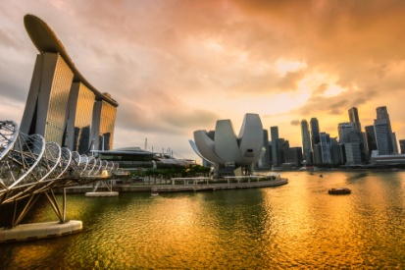
PHILIPPINES
Department of Tourism
DOT Building, T.M. Kalaw Street, Agrifina Circle, Rizal Park
Manila 10004, Philippines
Tel. (632) 523 8411 Fax. (632) 521 7374
Email: deptour@info.com.ph
Website: http://www.wowphilippines.com.ph/
SINGAPORE
Singapore Tourism Board
Tourism Court, 1 Orchard Spring Lane, Singapore 247729
Tel. (65) 736 6622 Fax. (65) 736 9423
Email: stb_sog@stb.gov.sg
Website: http://www.yoursingapore.com/


THAILAND
Tourism Authority of Thailand
1600 New Phetchaburi Road
Makkasan, Ratchathewi, Bangkok 10400, Thailand
Tel. (662) 250 5500 Fax. (662) 253 7437
Email: center@tat.or.th
Website: http://www.tourismthailand.org
VIET NAM
Viet Nam National administration of Tourism
80 Quan Su Street, Hanoi, Viet Nam
Tel. (84-4) 822 8744 Fax. (84-4) 942 4115
Email: binhvnat@hn.vnn.vn
Website: http://www.vietnamtourism.com

Tourism Boards
In some countries such as in Singapore, a ‘tourism board’ have been established. It is called the Singapore Tourism Board. The primary task of STB was to coordinate the efforts of hotels, airlines and travel agents to develop the fledging tourism industry of the country.
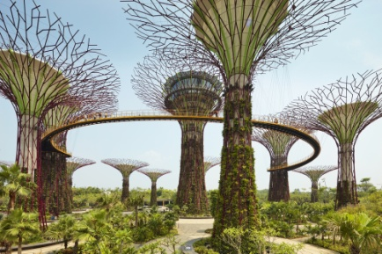
Later, STB began to initiate new marketing ideas to promote Singapore's image aboard. The board created the Merlion, a symbol based on a Singapore mythical legend that became an icon of the Singapore destination. The board also has been providing travel agent licensing and tourist guide training.
STB actively promotes the development of infrastructure, including the building of hotels and tourist attractions such as the Jurong Bird Park and Sentosa which now becomes a popular resort island for both tourists and local visitors. The board also market the city as a convention venue and organised events to attract visitors.

Industry Authorities
Authorities are established, either by a government or working closely with government to provide services relating to the tourism industry.
One such example is the ‘Tourism Authority of Thailand - http://www.tourismthailand.org/about-thailand/
It is the official travel information website for tourists visiting Thailand and contains all information to ensure visitors have all the necessary information to help them plan and enjoy their travel experience.

Industry Associations
Industry associations are bodies that all businesses can elect to join that serve specific and over-arching industry sectors. These bodies provide businesses with a variety of services which can include:
- Representing the industry – this means they act as an industry spokesperson to unions, the media and government
- Legal advice – about industrial relations issues, OS&H
- Training – to management and operational staff
- Industry standards and benchmarks – which member bodies can elect to implement as their standard practice
- Cost savings – by virtue of establishing for their members a range of discount rates for products and services from industry suppliers.
Many have newsletters, magazines or regular mailings of some sort to keep the membership up-to-date with what’s happening. Ask you supervisor if your workplace is a member of such a body and ask if you can read the newsletters etc.

Industry associations include:
- Australian Federation of Travel Agents - www.afta.com.au
- International Air Transport Association - www.iata.corg
- Pacific Asia Travel Association - www.pata.org



Activity 1- Identify tourism businesses

For each type of tourism business listed below, provide examples of actual organisations in which you would request information from.
Type of tourism businesses | Names of organisations
Airlines
Other travel suppliers
Cruise operators
Railway operators
Bus lines
Car rental businesses
Limousine hire / taxis

Type of tourism businesses | Names of organisations
Travel insurance providers
Finance providers
Currency exchange
Conference and similar venues
Interpreters
Accommodation
Hotels and motels
Guest houses
Bed and breakfasts

Type of tourism businesses | Names of organisations
Caravan parks and camping grounds
Resorts
Time share properties
Apartments, villas and cottages
Conference and exhibition centres
Attractions and theme parks
Museums and galleries
National parks, wildlife parks and gardens
Theme parks
Heritage sites and centres

Type of tourism businesses | Names of organisations
Sport and activity centres
Aquarium and zoos
Tour operators
Inbound Tour Wholesaler
Outbound Tour Wholesale
Retail Travel Agents
Local, regional and National information services
Meetings and Events
Corporate Agents

Type of tourism businesses | Names of organisations
Ministries of Tourism
Tourism boards
Industry authorities
Industry associations




Identify types of product and services information

As can be seen above, there are many types of tourism related businesses. The information provided by each will be valuable and essential in providing information and advice to your customers.
Following, are types of tourism related information that should be gathered as it will be required to provide accurate advice to customers.

Destination information
In order for you to be able to provide your customers with advice about destinations, you need to have good background knowledge of sought after tourism destinations. This can include those in your country, region or worldwide.
Destination information may include:
- General destination information
- Statistical information

- Currency
- Maps
- Travel guides
- Events
- Languages
- Safety
- Government information
- Time zones
- Communications.

Local community information
Staff should have a thorough understanding of:
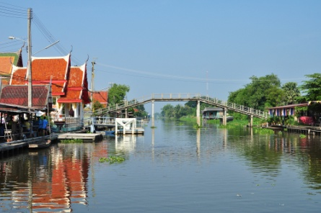
- Local attractions
- Shopping and retail areas
- Events and festivals
- Eateries
- Supermarkets
- Local transport
- Activities
- Places of worship.

International destination information
When providing information on international destinations to your customers, you will need to advise them of the government regulations that apply when people wish to leave the country.

In addition to passport and visa information, you will need to inform your customers of the health and safety precautions of each particular destination and any customs regulations that apply.
A visa is a stamp or document placed in passports by an authorised representative of a country, permitting passage to a country and allowing the visitor to remain there for a limited amount of time.

Tours
You should be aware of the types of tours on offer in a destination.
Different customers will be interested in different types of tours, so it is important that you have a good selection for them to choose from, for example:
- Multi-day bus tours with a guide
- Walking tours
- Special interest tours
- Cycling tours

- Drive yourself tours
- Low budget tours.
Tour information
- Company name, name of tour and duration
- Departure date, time and location address
- End date, time and location address
- Type of accommodation e.g. single, twin-share
- Tour company specific baggage labels
- Hotel list – names, address and telephone numbers for hotels used on tour
- Tour information booklet
- Included services – arrival and departure transfers.

Attractions
Probably the most important single feature is that a destination must have an attraction.
Attractions can range from a notable historic site, to a scenic location, or a place where some special event is taking place.

Attractions have value in themselves, but they are also evaluated by the traveller from several viewpoints. One aspect of importance is the positive ‘distance-pull’ of an attraction. In simple terms, this means that an attraction must have enough appeal to make it worthwhile for the traveller to make the journey.
Each attraction has a different ‘distance-pull’ and each individual traveller has his or her own set of values that influences how they evaluate the distance-pull of the attractions.
Every country can claim to have some attractions that might be of interest to a customer.
It is important to remember that tourist attractions can be:
- Natural
- Man-made.

Activities
Attractions are the main reason for choosing a specific destination. However, it is necessary at most destinations to provide for some activities to supplement the major attractions.

These activities are established so the tourist will have ‘something to do when there is nothing to do’! Activities give the tourist something to do when the weather is inclement and after dark.
Going on a nature walk, attending a minor sporting fixture, playing golf or tennis are examples of activities tourists participate in while at their destination. Activities are there for casual enjoyment.

History
Many people are interested in history, and therefore information on the history of a destination can be important to customers. History adds colour and life to a destination.
Knowing what has happened in the past will give an insight into the destination as it is today.

Geographical features
Geographical features include:
- Mountain ranges

- Lakes
- Rivers
- Caves
- Waterfalls
- Rock formations
- Beaches
- National parks.
Your customers may want information on the geography of a destination because it contributes to the reason why they want to travel to this destination.

Local customs and culture
Every destination will have customs that are specific to that place and that particular culture. These will most likely be of interest to your customers.
Each destination is unique and may have language and customs which are quite different from your own.
Although this may be the major reason for the country’s attraction, it is also important that these differences are respected.

Climate
It is important that you understand the weather conditions and patterns of the destination.
Your customer will need to know what the weather is like so that they know what they need to take with them and whether they will cope in these climatic conditions.



Accommodation
As previously mentioned there are a wide range of accommodation options, ranging from five-star hotels to budget accommodation.
Information that needs to be sought in relation to accommodation includes, but is not limited to:
- Room types
- Tariffs

- Products and services
- Room facilities
- Location and distance to attractions
- Packages
- Blocked dates
- Seasons and times
- Minimum purchase
- Booking and stay requirements
- Property name and address
- Room type and category
- Number of nights
- Check-in and check-out dates
- Check-in and check-out times
- Day use or late check-out if applicable
- Inclusions e.g. full buffet breakfast, arrival drinks, fruit basket
- Extra charges payable direct e.g. rollaway bed
- Special requests e.g. cot, double bed
- Special promotions e.g. hotel meal credit per room per stay.

Amenities and services
Amenities and services refer to the provision of basic services for travellers including:

- Toilet blocks
- Water
- Electricity
- Food and beverage including restaurants, cafes, bistros
- Medical services
- Banks and post offices
- General safety facilities including fire, police emergency services
- Entertainment
- Sporting
- Shopping.

Airlines
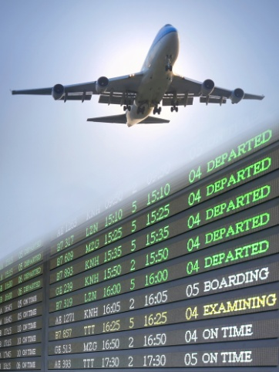
- Airline or combination of airlines
- Airport codes
- Airline codes
- City codes
- Flight numbers
- Schedules / timetables
- Destinations
- Routing
- Origin and destination
- Code share flights
- Normal fares
- Discounted fares, including infants, children, students, pensioners and groups
- Fares for unaccompanied children
- Promotional fares and packages
- Taxes
- General air travel rules and restrictions of the host country, including regional requirements, where applicable
- Class of travel
- Stopovers
- Mileage restrictions allowed
- Minimum and maximum stays
- Ticketing time limit
- Payment conditions.

Car hire
- Company, category, type

- Pick-up and drop-off depots, the depot addresses and opening/closing times
- Pick-up and drop-off dates and times
- Inclusions and exclusions e.g. unlimited kilometres, insurance and taxes
- Special requests e.g. baby seat, ski rack, GPS
- Notes e.g. a valid international driver’s license is required.

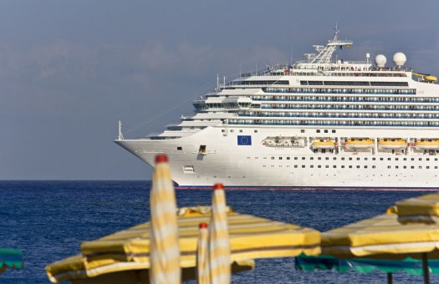
Cruises
- Name of the ship and voyage number
- Embarkation date, time and port address
- Disembarkation date, time and port address
- Grade/category and cabin type and number
- Passenger dining preference
- Pre-booked special requirements e.g. gluten free diet, wheelchair.

Transfers
- Name of company providing the transfer
- Local address and local telephone contact number of company providing the transfer
- Type of transfer e.g. private car, seat in coach, airport shuttle
- Pick-up date, time and location including address or terminal number
- Drop-off date, location e.g. Park Royal Hotel, Singapore
- Special instructions in relation to transfer.


Rail
- Name of Pass
- Duration and type of pass e.g. 3 Day Adult or 4 Day Flexi
- Validity dates.

1.2 Determine usefulness of product information sources

Introduction
Whilst there are endless pieces of tourism related information available, it is essential that you are focused on collecting information that will be useful in relation to providing relevant and tailored advice and services to your customers.

Importance of having useful and appropriate product knowledge
It will be up to you to determine exactly what product and industry knowledge will be useful to meet the needs of your customers.
For all businesses within the tourism industry, it is important to have relevant and up-to-date information so you can:
- To demonstrate the professionalism of the business and your individual level of professionalism and expertise
- To answer routine questions that customers and guests expect you to be able to answer
- Provide destination information and advice to all types of customers
- Provide specific product advice to all types of customer
- To provide additional information which will enhance the customer’s appreciation of their stay, the product they have bought or the service they have booked
- To advise customers of up-coming events, specials etc that the venue plans to offer
- To make recommendations and suggestions when asked for your opinion
- Selling tourism products to the customer

- Quote specific individual tourism product prices
- Booking and coordinating a supplier service for the customer
- Receiving and processing a reservation from a customer
- Processing financial transactions
- Issuing customer travel documentation
- Issuing itineraries
- Participate in product launches and explain the features of the products
- To generate repeat business from customers
- To generate referral business
- To comply with general operational requirements.

Assessing information needs
When assessing information needs, do not get overwhelmed with too much information. Only seek out the information that you need. The following questions can be of assistance when assessing information needs.

- What types of decisions are you regularly called on to make?
- What types of information do you need to make these decisions?
- What types of information do you regularly get?
- What types of information would you like to get that you are not now getting?
- What information would you want daily? Weekly? Monthly? Yearly?
- What specific topics would you like to be kept informed of?
- What types of data analysis programs would you like to be kept informed of?
- What do you think would be the four most helpful improvements that could be made to the present information system?

1.3 Identify items that may contain product information

Introduction
As can be seen in the previous section, the need for information will often determine the type of information required to suit the desired audience.
This section will explore the different types of information that can be collated and used by organisations for a variety of reasons.
Text-based information
Text based information is the most commonly used form of information for tourism businesses and includes:
- Brochures, flyers and pamphlets
- Product manuals
- Supplier information and sales kits
- Confidential and general industry tariffs

- Preferred contracts or agreements
- Clue cards
- Fare sheets
- Industry publications, advices and notices
- Media articles
- Travel literature
- Travel guides
- Newspapers and magazines
- Timetables
- Reports
- Summaries
- Marketing materials and books.

Image-based material
Whilst images are often included in text based information, specific image based material can include:

- Photographs
- recordings
- Videos
- Posters
- Atlases and maps.
Statistics
Purpose of statistics
Statistics is the study of the collection, analysis, interpretation, presentation, and organisation of data.
Statistics are valuable tools for all businesses, regardless of industry, as they provide factual evidence that can be used to:
- Identify true performance or activity of organisations, staff and customers
- Identify trends and patterns of existing and potential customers

- Identify areas of good performance which can be exploited
- Identify areas of performance that are substandard
- Identify causes of poor performance
- Identify opportunities for business improvement
- Guide future strategic direction of an organisation.
Statistics can include information relating to:
- Industry as a whole
- Specific to your business.
Industry statistics
- Types of tourism businesses
- Types and demographics of customers
- Top destinations

- Hotel occupancy percentages
- Reasons for stays
- Current industry information
- Destination countries
- Departure months
- Length of stay
- Type of organisation for the trip
- Transport mode
- Accommodation type
- Expenditure.
Business statistics
- Operational performance
- Financial performance
- Spending patterns of consumers
- Characteristics of consumers.
Testimonials
Naturally any testimonial that is collected by a tourism organisation is a valuable asset that can be used to provide an accurate reflection on the performance of the organisation or an individual staff member.
Testimonials are very good marketing and promotional tools as they are statements from actual consumers, not messages given by organisational staff.
A testimonial can be a formal statement testifying to:
- Someone's character, performance, professionalism, qualifications, skills or achievements
- The virtues of a company and the products and services it provides

- How the experience benefited them on a personal basis.
Ideally testimonials should include the person's:
- Name
- Title
- Company
- Head-shot photograph.

Specifications
A specification refers to the manner in which a good or service is to be provided. It needs to be complete, concise and unambiguous. It may be one page in length if relating to an official purchase order, with terms and conditions printed on the back.
Or it could be a collection of drawings, general and specific terms and conditions and a separate multi-page specification detailing the product or service requirements.
Work or equipment specifications

Work or equipment specifications may relate to:
- Description of equipment or work to be provided
- Standard of equipment or work to be provided
- Purpose of equipment or work to be provided
- Design or capability requirements.
Quotations
Quotations are used by tourism and travel organisations to sell their products and services, through the use of suppliers, summarised in a way that adds value for the customer.
Information commonly included in a quotation includes:

- The Travel Agent detail (Agency letterhead/logo)
- The passenger names
- The products or services booked
- Inclusions and exclusions
- The status of the items
- The gross price – usually quoted per person
- The conditions of booking, amendment and cancellation
- The payment schedule for deposit and final money
- Information relating to other travel documentation including visa requirements, travel insurance, destination information etc.
Personal observations
Naturally one of the best types of information that can be used by an organisation is that which has been personally collected.

This includes:
- Personal notes
- Report and findings
- Log books
- Records of interviews
- Notes of first-hand meetings.

Activity 2 - Identify key tourism information for a variety of trips

You are to identify the different pieces of information that you would require if you were to plan one of the following trips:
- 3 week trip for a family of five persons (parents aged 50-60 with children aged 17, 11 & 5) to Europe. They want to visit at least 3 countries and are interested in seeing key attractions and also age related recreational activities for the children

- 3 week Cruise around Caribbean for an elderly couple
- 1 week budget adventure trip in an ASEAN country for a couple aged 25
- Luxury1 week trip to an ASEAN country for a couple aged 60
- Business trip for a group of 5 persons to a major ASEAN city. They need to book a conference room for 10 persons for 4 days and then incorporate sightseeing for a day after business has been completed.
For the purpose of this exercise, the clients come from your own home town.
What are key pieces of information you would gather? | What items / format did the information come in? | How did you determine the usefulness / appropriateness of the information?

Work Projects
It is a requirement of this Unit you complete Work Projects as advised by your Trainer. You must submit documentation, suitable evidence or other relevant proof of completion of the project to your Trainer by the agreed date.
1.1 Please complete the following activities relating to this Performance Criteria:
- Activity 1
1.2 Please complete the following activities relating to this Performance Criteria:
- Activities 1,2
1.3 Please complete the following activities relating to this Performance Criteria:
- Activities 1,2

Summary

Identify and evaluate sources of product information
List potential sources of product information
- Product and service knowledge
- Summary of tourism products and services
- Tourism industry organisations
- Airlines
- Other travel suppliers
- Suppliers and providers of support and ancillary services
Accommodation
Attractions and Theme Parks
Tour Operators
Inbound Tour Wholesaler
Outbound Tour Wholesaler
Retail Travel Agents
Local, regional and national information services
Meetings and Events
Ministries of Tourism
Tourism Boards
Industry Authorities
Industry Associations
- Identify types of product and services information
Destination information
Local community information
International destination information
Tours
Attractions
Activities
History
Geographical features
Local customs and culture
Climate
Accommodation
Amenities and services

Airlines
Car hire
Cruises
Transfers
Rail

Determine usefulness of product information sources
- Importance of having useful and appropriate product knowledge
- Methods of determine usefulness of product information
- Assessing information needs
Identify items that may contain product information
- Text-based information
- Image-based material
- Statistics
- Testimonials
- Specifications
- Quotations
- Personal observations

Element 2:
Access product information

2.1 Select appropriate sources of product information

3.1 Identify specific sales needs that form the basis for the search for product information

Introduction

As mentioned in the previous section, when you are seeking tourism information to access and interpret to meet the needs of your organisation and its clients, it is important that it is relevant and useful.
This section will identify the steps associated with collecting information, starting from the identification of sales related needs, through to the steps taken to collect and access information.
Specific sales needs
Ultimately the goal of collecting and accessing information is to provide the best possible service and to meet the client’s needs thus enabling you to make the sale and process the booking.
The first step in collecting information is to identify the needs or reasons why collecting information is essential.
Specific sales needs may relate to:
- Consultation with client – in person, via telephone or email

- Non-negotiable client needs, including budget, timing, duration of travel, required destination and activities, health
- Requests from and preferences of client, including general enquiries and special interest requests, travel preferences, timing and designated destination activities
- Source and provide information and advice
- Make recommendations
- Check availability and prices
- Provide quotation including booking terms and conditions
- Processing a reservation, including booking and coordinating supplier services and products
- Collect applicable deposits and provide to applicable parties
- Provide written confirmation and due dates for final payment
- Collect final payment and provide to applicable parties
- Processing financial transactions, including payment of deposits and full-payment for bookings

- Issue or secure non-air and air travel documentation and provide to customer
- Need to amend an existing booking due to unforeseen circumstances
- Cancellations or alterations made to bookings.
One of the keys in gathering key pieces of relevant information is to carefully yet effectively search for information.
It is important that you have identify a clear topic of your search and to identify objectives of what you are trying to achieve when searching for information, otherwise you can very easily become side-tracked and spend considerable time looking for information that may not be relevant.
Define search topic and objectives

The first step is to try to identify exactly where the focus of research and information collection should be concentrated on.
The research topic may not be obviously apparent and it is often difficult to define.
Exploratory research can help to better clarify the topic and set some objectives of what we want the research to achieve.
The statement of the research topic and objectives should guide the research plan and process.
Determining specific research topics
The research topic and research objectives must then be translated into specific research questions that address particular information needs.
By having established research questions, they can help guide the objectives of the research.
Define research objectives
By having a clear understanding of what questions and objectives you wish to gather information on, it provides a clear focus in which to guide the research process.

Methods to access information from identified sources
In the next few sections, the ways to access information from both external and internal sources will be defined in detail. That said, common ways to access information from sources include, but not limited to:
- Subscribing to, and reading, industry magazines, newsletters, updates
- Picking and reading through the local and city newspapers – especially those sections that carry articles on hospitality, tourism, and events

- Getting on Internet e-mail lists and receiving newsletters and updates from the vast number of relevant industry government agencies, suppliers and support services
- Joining your local union or industry association to receive regular material – and taking an active interest in the issues that are foremost in their minds
- Reading books on the industry sector that you are working in – you should aim to read widely and include biographies of industry people, management texts, practical hands-on reference material and general literature on diverse industry topics
- Getting out and having a look around to see what’s happening, what people are doing, what the competition is doing, and what people are doing and saying

- Interrogating databases - looking at data bases. In many cases, vital information may already be filed in your own systems
- Asking questions - if you are unsure of the information or want to identify background information or reasoning behind data, it is important to ask questions so you are clear as to how the information came to be
- Conducting web based searches, including the use of search engines and bookmarked sites relevant to the industry and enterprise
- Exploring options - even though this manual to date has identified a number of sources and methods for collecting information, at times you will need to be creative and think 'outside the box' to gather additional information or from a different perspective.
One of the most important aspects of searching identified sources is to write down, collect or summarise what you find out from all of these sources. You will forget most of what you manage to find if you don’t collate it using an appropriate system.

Identify timelines for information required
Not only is it important to identify the types of information needed, but also when it needs to be collected and available for use.
Whilst it is impractical to collect, update and communicate all information on a daily basis, thought must be given as to when it is essential for staff to obtain necessary information to meet the needs of customers
Naturally the urgency and importance of the information will dictate how quickly it will be collected.
For example if new visa or travel advisories or restrictions are introduced, this information will need to be researched and communicated to clients who have either booked or are considering travel to affected locations.

Considerations when identifying timelines for information
When deciding on the timelines to access information considerations that must be identified include:
- Resources required to access and interpret information
- When to conduct research and collect information
- When to analyse and review the information
- Who needs the information

- What is the best way to pass on information on to other stakeholders at one time
- Informs stakeholders of the key aspects of the information
- Provide advice how this information can be used to the benefit of the organisation and potential or existing customers.
Identify timelines for accessing information
Timelines for accessing of information may be:
- Immediately - taking into account all tasks prioritised as urgent

- As soon as possible
- Within a designated timeframe, which specifies a number of hours, days, weeks or months, including tasks to be completed before the set deadline
Regular cyclical events in accordance with designated enterprise policies which, for example, may include:
- The need to review supplier wholesale prices every month
- The need to update customer data every three months
- The need to gather destination, supplier and carrier information for new or revised packages every season.

Identify budget for accessing and interpreting information

A great deal of time and effort is required to access and interpret information and therefore most tourism organisations will develop a budget specifically for the nature of this activity.
It is essential to have a budget in place to ensure financial transactions relating to sourcing and presenting information are controlled.
Budgeting considerations
Budget considerations may include:
- Time allocation to undertake research

- Staff to undertake research or assist in the analysis, preparation and presentation of the material captured
- Funds to obtain secondary research data
- Funds to enable the undertaking of primary market research
- Materials, registrations, subscriptions and other activities necessary to register to receive or to purchase identified information.

Identify information found
Once you have searched and found relevant information, it is important to 'identify' relevant information so that it can be used again for the purpose or filing, further review or use in operational activities.
It is important to 'mark' the information so that is can be easily found for future use.
Methods to identify relevant information include:

- Book marking websites
- Recording sources in a project-specific index
- Copy and pasting key points into separate files
- Highlighting key information
- Filing documents in a logical order.



Activity 3 - Source information

Based on the trip you have identified in Activity 2, you are to outline the strategy you would you to source appropriate information.

Description of tour:

Possible needs of the customer:

Sales needs:

Search objectives:

Key topics | Method of collecting information |  | Timelines | Resources / Budget
 | External | Internal

2.2 Register to receive and/or access product information

2.5 Access external sources of product information

Introduction

Once you have identified the types of information you wish to gather from different sources, it is now time to contact them and request information to be sent to your organisation.
In most cases, especially relating to tourism businesses will be more than happy to provide information about their businesses as it will hopefully lead to greater awareness and sales of their products.
Whilst it may seem like a simple activity, there are a number of objectives that must be achieved when touching base with sources when arranging to receive information.
Where possible, try to make the formats selected the most 'user friendly' and cost effective for both the supplying organisation and yourself.
That said, two of the most commonly requested formats of information is through the use of brochures or electronic files.
Objectives when contacting external sources
There are a number of objectives associated with contacting tourism businesses. These include:
- Making contact with tourism businesses
- Introducing your business to the organisation

- Identify if the tourism business 'fits' your company profile or image
- Gain an understanding of the tourism products and services they provide
- Understand their 'promotional message' and how to promote their products and services
- Discuss contractual agreements and terms and conditions for working together
- Requesting product information.

Making contact with tourism businesses
Naturally there will be a number of suitable ways in which to make contact with businesses. Given that most tourism businesses may not be in your immediate geographical location, personal face to face contact is not possible.
Methods of contacting businesses include:

- Telephoning targeted businesses
- Making face-to-face requests of sales staff that visit the office
- Making e-mail requests
- Registering to receive information, newsletters and up-dates.
Introducing your business to the organisation
Given that you are the person who has initiated the contact it is essential that you introduce yourself to the tourism organisation.
Like in any partnership, both partners must gain an understanding of whom they may wish to work with.
When introducing your organisation to tourism businesses, information to be communicated include, but not limited to:
- Name of company
- Location

- Licence Number
- Key contacts
- Products and services provided
- Identification of their clients - including size of client base, history of previous sales, potential sales
- Competitive advantages of your organisation
- What you are seeking in a partnership.
Identify if the tourism business 'fits' your company profile or image
For any successful partnership to take place, both companies must work with companies that match or reflect their own image and vision.
When companies work together, the practices of one of the businesses will impact on the brand of the other.
Therefore it is essential that both organisations carefully select business partners that compliment what they do themselves. The key is to provide mutual benefit.
Normally travel companies will only associate with tourism organisations that offer 'suitable ' offerings to the type of client they attract. For example, if a travel agency aims at the luxury market they will not bother to contact budget accommodation facilities, however will focus towards high end hotels, resorts and cruises etc.

Tourism companies will not want to work with travel agents who operate in illegal, immoral or dubious manners. This includes the provision of inaccurate information or availability as a method of generating greater revenue for themselves.
In addition, travel agencies do not want to work with tourism organisations who provide 'non-professional' products and services to clients. This can include substandard accommodation conditions, products that do 'not match' what is advertised in brochures or hidden 'booking conditions' that clients only find out about once they are a the venue themselves.
Gain an understanding of the tourism products and services they provide
One of the most important aspects of contacting a tour company is to gain an understanding of what they can offer to your client.
Naturally through the use of brochures and websites etc a travel agent can gain a thorough understanding of what the business offers, in terms of products and services, however there may be aspects that require further clarification.
The more information you can gather about a tourism business, the better it will be in being able to provide accurate information to clients and to answer any questions they may have.

Identify key features and benefits
A tourism organisation has a greater understanding of their own products than a travel agent ever would.
Therefore it is beneficial for them to identify the features and benefits of the products they provide.
A feature is the characteristic of a product, e.g. hotel (product) has a swimming pool (feature). “The pool will be relaxing and cool you down after a full day of sightseeing in hot weather (benefit)”.
Ask questions
Information you may wish to collect may include:
- Key products and services
- Key reasons why people visit their business
- Key questions or queries potential customers may have
- Key pieces of information potential customers must know
- Key information not identified in brochures, websites etc.
Arrange familiarisations

One of the best ways to understand a tourism organisation is to visit the establishment and 'experience' it like a customer would. Familiarisations are the best way to gain a firsthand understanding of an organisation
Also known as educationals, these are free trips offered by suppliers to travel agents to sample products or services firsthand.
Understand their 'promotional message' and how to promote their products and services
With the aim of consistency in their promotional message, all tourism businesses will have a 'specific message' in which they wish to convey to all potential customers, regardless of how they enquire or book products and services.
Identify their promotional activities
One of the best ways to gain an understanding of the promotional messages of a tourism business, is to understand the promotional activities they are conducting. These activities are designed to grab a customer’s attention to create a sale, e.g. advertising, product launches/marketing.

Identify their special offers
All customers want special deals. It is therefore essential to identify and understand any special offers your customers can take advantage of. Special offers are for sale on a limited basis, either in terms of time or availability. Some are discounted prices, e.g. early bird bookings, while others are normal cost with extra items included for free during the validity of the special offer.
Discuss contractual agreements and terms and conditions for working together
As mentioned before, the aim of any partnership is to gain mutual benefit.
Therefore an important part of any partnership is to outline the terms and conditions of the partnership.
Commercial agreements
Also commonly known as preferred product agreements, these are the agreements between suppliers and travel agencies with regards to sales targets, levels of commission and incentives.
By establishing commercial agreements, the travel agency receives higher agent’s commission levels for selling the supplier’s products in preference to other similar products.

Contract of sale
Besides having an overriding commercial agreement, there needs to be clarification of when a 'sale' has been made. This involves a legal agreement which includes all the booking conditions which apply when a booking is made.
Contract rates
It is important to understand if these are any special rates between a supplier and travel agency.

Incentives
Under the concept of mutual benefit, any incentives available for either party must be negotiated.
This includes identifying any rewards to be given for selling a particular product or service. Rewards can be extra commission or benefits to staff. There are usually a number of conditions which apply.
The most common form of incentive is through the provision of commissions. Commissions are the money paid to a travel agency for selling a product or service. It is calculated as either a percentage of the total sale, e.g. 10% or a dollar amount. The commission paid to an agent is a part of the commercial agreement which agents have with principals and suppliers.

Bookings, confirmation and conditions
This refers to the procedures required to book tourism products, e.g. deposit amount and due date (usually required within seven days of confirmation) and date final payment is due (usually 30-60 days prior to departure date).
The booking conditions detail the specifications of service providers. These may include deposit and final payment conditions, inclusions, exclusions, room configurations, rates, tariffs, seasonal factors, taxes etc.
Requesting product information
Once all necessary arrangements have been made it is now time to request product information.

Where possible, try to make the formats selected the most 'user friendly' and cost effective for both the tourism organisation and yourself.
That said one of the most commonly requested formats of product information is through the use of brochures.
Brochures contain information on a tourism destination, a particular product or package and are still the main selling tool in the travel industry



Activity 4 - Contact key tourism organisations

Based on the trip selected in Activity 2, please identify how you would contact tourism organisations to gather information to help provide a quotation for the client.

Type of organisation | Method of requesting information | Information to be requested | Format of information

Registering for information
When sourcing information, whilst direct contact with external providers, as mentioned above is an invaluable way to get information regarding specific products and services, quite often you may need to gather more generic information relating to the industry as a whole, including any new laws, regulations, businesses or trends.
This information will commonly be obtained through various publications, produced by leading government or industry leaders and authorities.
In order to access this information you will need to register to receive it.
Registering for industry information may include:

- Registering on-line
- Paying a fee
- Establishing required password and username, if required
- Lodging host enterprise details with product information source
- Establishing the bona fides of the host enterprise
- Joining an association or body in order to enable access.



Activity 5 - Identify publications to register

If you were a travel agent / tourism operator in your country, what are examples of publications, either in hard copy or online, that you would register to access valuable information that would suit your organisation.
Name of publication | Format of publication | Reasons for registering to publication | Key features | Cost

Seeking external assistance
Whilst you may have collected considerable information on your own accord, or gathered using external organisations or publications, at times you may be required to seek external assistance for a number of reasons.
Whilst each organisation will have their own purpose, common reasons include:

- To gather further information
- For acquisition of specialised information
- To interpret existing information gathered
- Provide findings and recommendations
- To clarify information
- To answer any questions.
Types of external assistance
Types of external assistance includes, but not limited to:
- Government agencies
- Libraries
- Professional external third party information providers
- Trade, professional and business associations.
Establishing industry networks
Developing your own industry network
As a member of the tourism industry, it is vital to build your industry network. This involves reaching out to all people in all aspects of the industry and discussing industry happening, trends and current information. The more people you meet and the more information you accumulate provides you with a sound understanding of the industry and will help your career progression.

Networking with industry colleagues
It is very worthwhile to network with industry colleagues when you get the opportunity to attend product launches, seminars, educationals and the like.
You are not only constantly learning but you are also mixing with other tourism professionals, many of them having knowledge, experience and skills that you do not have.


Activity 6 - Creating an industry network

You are to identify seven (7) possible contacts whom you would like to invite to an industry network you would create.
This network can be used for whatever purpose you decide, including seeking assistance and advice or to share ideas.

Desired contact | Contact details | Purpose of inclusion in an industry network

2.3 Visit suppliers and other sources to talk with sales staff and obtain items that may contain product information

Introduction
In addition to making contact with external providers of tourism related information, at times you may be required to visit identified sources.
This opportunity to gather a first-hand understanding of the source, including key personnel who will be instrumental in sharing information is very beneficial.
Benefits of visiting identified sources
It is extremely advantageous to visit sources as they provide a first-hand opportunity to:
- Meet key personnel
- Talking with personnel to obtain, clarify, update and identify supplementary relevant information
- Gain an understanding of the operation

- Viewing operations and making personal observations
- Clarify and explain your request for information
- Receive electronic and hard copy files in a manner that is more user friendly than delivering them through other sources such as emails or courier services
- Reviewing additional information available at the source
- Get any questions answered
- Identify the potential of informational sources that can be utilised at a later date
- Recording interviews and taking photographs or other recorded images.


Activity 7 - Identify desired visits


For each of the following points, you are to identify one (1) company you would wish to visit to help you to:
- Access information for your trip in Activity 2
- To gather general information that would help a travel and tourism establishment.
Access information for your trip in Activity 2
Name of company
Contact Details
Focus of the visit
Activities you would like to undertake as part of the visit
Information you would wish to collect as part of visit

To gather general information that would help a travel and tourism establishment

Name of company
Contact Details
Focus of the visit
Activities you would like to undertake as part of the visit
Information you would wish to collect as part of visit


2.4 Access selected internal databases and internal business systems

Introduction
To date in Section 2 we have explored the ways to access information through external channels.

Besides gathering information from external sources, an invaluable source of information that relates to a tourism organisation is from the organisation itself.
In the majority of cases, information that is required as part of operational or customer service activities can be obtained through the investigation and extraction of data from internal information systems.
As you can imagine, collecting information from internal sources is certainly more cost and time effective than sourcing from external sources. Therefore it should realistically be the first place to look when seeking information.
Not only will it be 'on hand', it is often tailored to the needs of the operation and can identify more accurately what is happening inside the business more than information obtained externally.
Types of internal information sources
Internal information may be obtained from a number of different sources depending on the scope, nature and technological capabilities of the host enterprise and may include:
- Customer databases
- Sales figures

- Internal reports
- Accounting and operational statistics
- Data from sub-agencies and head office
- Customer feedback information
- Automated information systems
- Computerised reservation systems
- Products and services inventories.

Utilising colleagues, supervisors and managers

These people are your first-line sources of information. You should feel free to ask them questions whenever you need to find information.
Get to know them and actively seek out their opinions, experiences and views.
They can help you find out what is happening, where the business is heading, what they think of the industry and its various stakeholders and what they intend doing personally.
Arrange to receive internal information
When seeing information from within the country, often the process will be easier.
Information may be sought from:
- Head Office
- Other businesses within the chain
- Management
- Colleagues
- Customers.
Quite simply requesting information may include:
- Asking internal colleagues to provide existing information through:
- Statistical and written reports

- Surveys
- Checklists & Flowcharts
- Meetings
- Discussions
- Emails
- Training sessions
- Requesting colleagues to manipulate existing data in order to generate new data
- Collecting information from a centralised 'share' drive
- Looking at the company 'intranet' site.

Access selected internal databases

Access selected internal databases may include:
- Identifying the types of databases / storage systems used
- Obtaining internal authority to access required fields of information
- Setting-up password access authority
- Determining folders, documents and locations to use.
Identifying the types of databases / storage systems used
When product information has been gathered and accesses, it is often filed for future use as deemed most appropriate by the enterprise and in-keeping with any relevant policies and procedures.
Every tourism operator will have their own method of filing and storing information. It is important to know where to look for certain pieces of information.
Your office will have a system of filing all information so that it is easy to retrieve. Check and make sure that you understand how the information is organised so that you can source it readily. It may be that your computer system is a sophisticated one and can handle the storage of all or most of the information. This may be supplemented by filing cabinets and manuals.

Options for storing product information
Product information inventory systems may be:
- Manual filing systems
- Computerised systems
- Combination of the above.
Regardless of the system used, it is important to remember that the focus of capturing and storing product information is to use it as part of the service delivery that the organisation provides to clients to help facilitate their travel needs.

Manual filing systems
Public area displays
Some form of manual filing system coupled with a public area display featuring racks and displays of brochures etc from various tourism businesses will usually suffice and is cost effective and operationally effective
The glossy brochures can be kept in the public display whilst more detailed and less frequently requested information can be kept in the file.
You may have product brochures displayed in the office for the public to access including a range of cruises and packaged tours, usually divided between domestic and international. In most tourism organisations there will be a range of individual local tour and accommodation operator brochures and general information brochures on the region and other regions.
Back of house storage areas
In the back room of the office there will be storage space for other product brochures which you may use if your preferred product is not available or does not offer what the customer wants.
A large range of timetables, insurance policies and other general tourism product information must also be on hand and it is imperative that you are aware of where this information is held.
Filing cabinets

Whilst the nature of the filing system to be used to store the information will be an individual choice, the use of cabinet drawers is a great option.
If you decide to use this option, make sure that whoever is to use this information can access these drawers readily and knows where things are in the file. There’s little point in the information being locked up where staff are unable to get to it or in having the information but being unable to locate where it is.
Suspension files
The use of these files with manila folders inserted can be used to divide the filing cabinet drawers up.
You will also have a large range of general destination information brochures and maps on countries and regions around the globe which should be logically filed for easy access and quick service for your customer. These may be divided between:
- Domestic and international destinations
- Regions
- Product types, for example cruises, tours, accommodation etc.


Personal information manual
You may choose or be required to compile your own personal information manual. You may have extracted a newspaper article or taken notes from a sales representative or local tour operator about information pertinent to your organisation. These also have to be filed logically and it is important to date all information to establish whether it is current and filed under the correct section.

Contact details of tourism businesses
If you are unable to obtain the information your customer requires from the sources within the office or simply need guidance on where to start, that’s when you refer to appropriate websites or phone the appropriate wholesaler or principal’s reservation or sales department directly for assistance. You will soon gain an understanding of which wholesalers or principals represent or package which part of the globe and what area they specialise in.


Activity 8 - Identify strategy for maintaining manual product information inventory systems

You are required to identify five strategies for maintaining manual product information inventory systems.

- __________________________________________________________________________________________________________________________________________________________________________________________________________________
- __________________________________________________________________________________________________________________________________________________________________________________________________________________
- __________________________________________________________________________________________________________________________________________________________________________________________________________________
- __________________________________________________________________________________________________________________________________________________________________________________________________________________
- __________________________________________________________________________________________________________________________________________________________________________________________________________________

Computerised systems
The travel marketplace is a global arena where millions of buyers and sellers work together to exchange travel services.
Among the “shelves” on which buyers search for travel services are world’s global distribution systems.
These systems have become electronic supermarkets linking buyers to sellers and allowing reservations to be made quickly and easily.
Nowadays, more travel is sold over the Internet than any other consumer product
A Global Distribution System (GDS) is a network operated by a company that enables automated transactions between third parties and booking agents in order to provide travel-related services to the end consumers. A GDS can link services, rates and bookings consolidating products and services across all three travel sectors: i.e., airline reservations, hotel reservations, car rentals, and activities.

The major GDS systems include:
- Travelport (Galileo, & Apollo)
- Travelport (Worldspan)
- Amadeus
- Sabre.

Activity 9 - Research a GDS system

You are required to research one of the above mentioned GDS systems and explain:
Purpose of this GDS
Products and service provided
Benefits for travel agents
Benefits for tourism suppliers
Benefits for customers
Policies and procedures
All tourism organisations will have a range of policies and procedures relating to the way in which product information will be managed.
In summary:
- A policy is a rule or statement
- A procedure is a step by step instruction on how a specific incident or activity should be conducted.

It is essential that all staff are able to understand the policies and procedures relating to information management in their role and the organisation.
Normally policies and procedures are explained during an induction or orientation period, during training or when new products are introduced.
All information relating to policies and procedures are distributed to all staff in handbooks, training manuals or job descriptions.
The purpose of having adequate policies and procedures relating to product information management is to ensure that product information is:
- Stored in a 'user friendly' manner
- Remains current
Examples of policies and procedures
The following examples are policies, procedures and standards that are required to be understood, met and followed by staff specifically working in visitor services.
These are normally delivered to staff during training, the initial employment period or when changes have taken place. They are normally delivered by outlet management, supervisors or fellow staff.
These are also located in job descriptions which are given, explained and signed by staff to ensure they are read and understood.
Policies
- Which systems to use
- Use of GDS's
- Amount of information to collect

- Responding to enquiries
- Scheduling of 'updating' product information.
Procedures
- Checking and updating information
- Sourcing product information
- Requesting product information
- Stocking product information.

Gathering information from customers
Understanding customers and their preferences is a very important aspect of a business.
Therefore being able to collect information is very important to understand what your business is doing well to meet their needs and to identify where improvements can be made. There are a number of formal and non-formal feedback methods can be used.
Asking customers for feedback:
- Verbal or written
- Individual or focus groups
- Structured or unstructured formats.
Formal feedback
This approach is used when established avenues have been established to collect information.

These approaches include:
- Customer comment cards – these are established documents aimed at getting responses to a wide range of questions covering all facets of an operation
- Interviews and follow up calls – at times management may contact customers to find out about their experiences or visits.
Informal feedback
This approach is a very effective way to get feedback. This information may come in the form of ‘gossip’ or ‘through the grapevine’, however is the provider of the largest amount of feedback.
Informal feedback involves collecting information and feedback outside the above mentioned formal avenues. This includes:
- General discussion – whether with fellow staff or with customers, by interacting with people, you can get a good feel of what people are thinking

- Observations – this is a great form of feedback. It is encouraged that staff observe the actions and reactions of customers and fellow staff. Most people are often uneasy about truthfully giving negative feedback, so this approach is useful in getting an accurate reading of what people are thinking in different situations.

Work Projects
It is a requirement of this Unit you complete Work Projects as advised by your Trainer. You must submit documentation, suitable evidence or other relevant proof of completion of the project to your Trainer by the agreed date.
2.1 Please complete the following activities relating to this Performance Criteria:
- Activity 3
2.2 Please complete the following activities relating to this Performance Criteria:
- Activities 3,4
2.3 Please complete the following activities relating to this Performance Criteria:
- Activity 7
2.4 Please complete the following activities relating to this Performance Criteria:
- Activities 8,9
2.5 Please complete the following activities relating to this Performance Criteria:
- Activities 4,5,6

Summary

Access product information
Identify specific sales needs that form the basis for the search for product information
Select appropriate sources of product information
- Specific sales needs
- Define search topic and objectives
- Methods to access information from identified sources
- Identify timelines for information required
- Identify budget for accessing and interpreting information
- Identify information found
Register to receive and/or access product information
Access external sources of product information
- Objectives when contacting tourism businesses
- Making contact with tourism businesses
- Introducing your business to the organisation
- Identify if the tourism business 'fits' your company profile or image
- Gain an understanding of the tourism products and services they provide
- Understand their 'promotional message' and how to promote their products and services
- Discuss contractual agreements and terms and conditions for working together
- Requesting product information
- Registering for information
- Seeking external assistance
- Establishing industry networks
Visit suppliers and other sources to talk with sales staff and obtain items that may contain product information
- Benefits of visiting identified sources
Access selected internal databases and internal business systems
- Types of internal information sources
- Utilising colleagues, supervisors and managers
- Arrange to receive internal information
- Access selected internal databases
- Identifying the types of databases / storage systems used
- Options for storing product information
- Manual filing systems
- Computerised systems
- Policies and procedures
- Gathering information from customers

Element 3:
Interpret product information

3.2 Read items that may contain product information

Introduction
In Section 2 of this manual, the different sources of product information and methods to source information has been identified.
Once information has been accessed, it is important that it is read and understood.
It is essential that not only do you understand the information you have accessed, but that it is accurate and relevant for the customers.
It is of vital importance that the information you provide to your customer is:

- Accurate
- Readily understood by the customer
- Provided in a timely manner
- Provided in an appropriate format and style
- Provided in an appropriate depth and scope.
These points will be discussed in more depth in Sections 3&4 of this manual.
If information is not accurate, not only can it make your organisation legally responsible for differences in prices or services provided, it will at the least cause major disappointment and frustration to customers who receive products and services which differ to that promised and anticipated.

Importance of accuracy
It is important that the information that you provide to the customer is accurate. There are many variables within tourism products that need to be identified, read, understood and checked before you can provide the information to the customer.
Therefore it is essential that you understand the information contained in brochures, timetables and other tourism information that you pass onto the customers

Methods to ensure accuracy of information
Methods to ensure accuracy of information include, but are not limited to:
- Identify date in which current information was compiled
- Checking version of the brochure or information
- Checking on the website for accurate 'real time' information
- Contacting the supplier to verify information.

Activity 10 - Reflect on consequences of 'inaccurate' information

You are required to reflect on a personal experience or 'case study' where the provision of inaccurate information has negatively impacted on a travel experience.

What was the inaccuracy?
What was the cause of the inaccuracy?
How did it impact on the customer?
How did it impact on the travel supplier?
How did it impact on the travel agent?




Read and review information
Once you have captured information that has been collect or given to you by various sources and organisations it is now time to read and review the information and determine its importance, accuracy and relevancy for your organisation and customers
Objectives of reading and reviewing captured information
Objectives of reviewing information that you have captured include:
- Verifying the accuracy, relevance and sources of the data - as mentioned above
- Confirming the applicability and utility of material researched and provided
- Determining degree of usefulness of the information

- Determining if additional information, material or data is required to meet identified needs
- Ensuring that no obvious sources of information have been overlooked
- Meeting with the information user to check that the material gathered is appropriate for their needs
- Meeting with researchers to clarify points of ambiguity, as appropriate.

Interpreting information
The aim of interpreting information is to analyse all the information collected with the hope of providing a summary of key pieces of evidence in which assumptions, conclusions and recommendations be based.
When interpreting information, it is important that the correct information is derived, in its intended format. Attempt to put the information in perspective to the objectives.
There may be vast amounts of information that has been collected. It is your role to identify which pieces of information are valid and purposeful, excluding information that is not relevant in answering the original objectives, or cannot be used to help substantiate or clarify findings.
The process is not to find reason or purpose in all the information collected, but to methodically compile and interpret evidence that is relevant.
Try to use the information to answer the research objectives and to provide supporting evidence to substantiate the findings.
Purpose of interpreting information
This serves a number of purposes including:
- Gaining further understanding of the information
- Identifying any questions you may have
- Identify the key points in which you may convey to stakeholders, colleagues or clients.
This process may include:
- Analysis and interpreting the Information
- Classifying the information
- Preparing summaries with supporting evidence of the results of the data analysis.

3.3 Integrate sourced product information with identified client needs and/or preferences

Introduction
Once you have reviewed and interpreted the information, it is now time to integrate the information to meet the needs of the organisation and the client.
Whilst there may be vast amounts of information that may be of benefit, it is time to identify:
- Which pieces of information do not need to be communicated or not relevant

- Which pieces or information are essential
- Key points that need to be communicated
- The order of priority for communicating information
- How to structure the information in a way that addresses original objectives or will be understood by the persons whom will need this information.
It is vital that the information that is needed by stakeholders, colleagues or clients is 'tailored' to their needs.
Activities associated with integrating sourced product information
Integrate sourced product information may include preparing a quotation that results from:
- Matching availability and data to identified client needs and preferences to the best extent possible
- Searching for possible alternatives and options
- Converting supplier codes and abbreviations into usable data to adequately interpret the information provided - these will be identified in more detail in Section 4.1.

Prepare the quotation to reflect all inclusions required by the customer
Quotations provide a summary of different options to address the needs of the customer.
In essence, the end result of accessing and interpreting product information is through the provision of a quotation.
Inclusions found in a quotation will differ depending on the needs of the client, but will commonly include:
General information
- Date of quotation and reference number (if applicable)
- Clients name

- Phone contacts
- Email address
- Address
- Dates of travel
- Length of travel and class of travel.
Travel products and services
Flights
- Airline details
- Destinations and routings
- Class of travel
- Departure and return dates – remember to include the year
- Fare validity – for sale and for travel dates
- Air fare per person
- Taxes per person (always state that these are subject to change).
Accommodation

- Name of accommodation and location
- Room type and bedding configurations
- Check-in and check-out dates
- Total number of nights
- Any extras or inclusions such as meals, transfers etc
- Cost per person per night and total amount for the stay.

Cruises
- Name of the cruise line or company
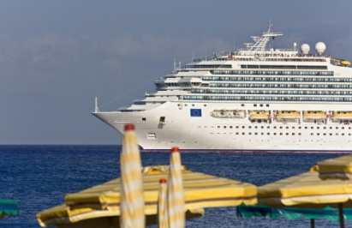
- Name of the ship
- Name of cruise, including code
- Number of days or nights
- Departure date, time and location
- Return date, arrival time and location
- Cabin type and deck location.
Tours
- Tour company name
- Tour name, code and duration
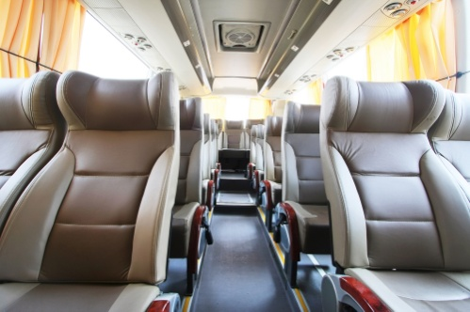
- Departure date, time and location/city
- Arrival date, time and location/city
- Rooming details – single, twin, triple
- Inclusions.
Other travel products and services
- Company used
- Products and services
- Inclusions / exclusions
- Costs.
Transfers
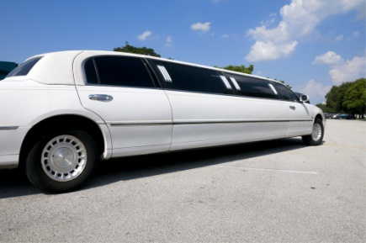
- Date, time and location of transfers
- Type of transfer – seat in coach, private transfers, limousine etc.
Car hire/Rentals
- Name of company they are using – Avis, Budget, Hertz etc
- Vehicle group or type – compact, midsize, group C etc
- Transmission – manual or automatic
- Pick up and drop off dates, times and location
- Rate – if paying direct
- Rental Inclusions – mileage, additional drivers, insurances, taxes
- Any additional local payments for additional services e.g. GPS.

Specific details
- Seasonality
- Availability
- Costing considerations
- Additional travel costs
- Product price increases

- Fluctuations in exchange rates
- Terms and conditions
- Scheduling information
- Product codes
- Booking procedures
- Points of departure and arrival
- Touring inclusions and exclusions
- Technical specifications for audio-visual and other meetings and events equipment
- Travel insurance
- Visa / permits
- Health permits
- Limitations
- Safety and risk – adventure products
- Non operation of the product – tour cancellation.
Key quotation protocols
Quotations must be provided in a format that can be easily understood by a client.
It is important therefore that the following general protocols are followed:
- Use official company stationery – letterhead or standard pro-forma document
- Date the quote
- Avoid the use of jargon
- Ensure correct spelling and grammar

- Include Customer/Passenger names
- Specify currency
- Provide both a per person and total price
- State validity of the quote
- Detail all the arrangements included in the quote – products, services, dates, times
- Follow a logical and sequential order for arrangements.
In Section 4, the process of providing information to customers, commonly through the provision of a quotation, will be identified in more detail.


Activity 11 - Prepare a quotation

Based on the trip you have selected in Activity 2, you are required to prepare a quotation that you would present to a client.
Please delete sections that do not apply to your client needs.
Client requirements / needs:
____________________________________________________________________________________________________________________________________________________________________________________________________________________________________________________________________________________________________
Summary description of trip:
____________________________________________________________________________________________________________________________________________________________________________________________________________________________________________________________________________________________________
Key aspects / inclusions of trip:
____________________________________________________________________________________________________________________________________________________________________________________________________________________________________________________________________________________________________

QUOTATION COMPONENT | INFORMATION / DETAILS
GENERAL INFORMATION
Date of quotation and reference number (if applicable)
Clients name
Phone contacts
Email address
Address
Dates of travel
Length of travel and class of travel
TRAVEL PRODUCTS AND SERVICES
Flights
Airline details
Destinations and routings
Class of travel
Departure and return dates – remember to include the year
Fare validity – for sale and for travel dates
Air fare per person
Taxes per person (always state that these are subject to change)

QUOTATION COMPONENT | INFORMATION / DETAILS
Accommodation
Name of accommodation and location
Room type and bedding configurations
Check-in and check-out dates
Total number of nights
Any extras or inclusions such as meals, transfers etc
Cost per person per night and total amount for the stay
Cruises
Name of the cruise line or company
Name of the ship
Name of cruise, including code
Number of days or nights
Departure date, time and location
Return date, arrival time and location
Cabin type and deck location

QUOTATION COMPONENT | INFORMATION / DETAILS
Tours
Tour company name
Tour name, code and duration
Departure date, time and location/city
Arrival date, time and location/city
Rooming details – single, twin, triple
Inclusions
Other travel products and services
Company used
Products and services
Inclusions / exclusions
Costs
Transfers
Date
Type of transfer – seat in coach

QUOTATION COMPONENT | INFORMATION / DETAILS
Car hire / Rentals
Name of company they are using – Avis, Budget, Hertz etc
Vehicle group or type – compact, midsize, group C etc
Transmission – manual or automatic
Pick up and drop off dates, times and location
Rate – if paying direct
Rental Inclusions – mileage, additional drivers, insurances, taxes
Any additional local payments for additional services e.g. GPS
SPECIFIC DETAILS
Seasonality
Availability
Costing considerations
QUOTATION COMPONENT | INFORMATION / DETAILS
Additional travel costs
Product price increases
Fluctuations in exchange rates
Terms and conditions
QUOTATION COMPONENT | INFORMATION / DETAILS
Scheduling information
QUOTATION COMPONENT | INFORMATION / DETAILS
Product codes
Booking procedures
Points of departure and arrival
Touring inclusions and exclusions
QUOTATION COMPONENT | INFORMATION / DETAILS
Technical specifications for audio-visual and other meetings and events equipment
Travel insurance
Visa / permits
Health permits
Limitations
Safety and risk – adventure products
Non operation of the product – tour cancellation
Work Projects
It is a requirement of this Unit you complete Work Projects as advised by your Trainer. You must submit documentation, suitable evidence or other relevant proof of completion of the project to your Trainer by the agreed date.
3.1 Please complete the following activities relating to this Performance Criteria:
- Activity 3
3.2 Please complete the following activities relating to this Performance Criteria:
- Activities 10,11
3.3 Please complete the following activities relating to this Performance Criteria:
- Activity 11

Summary

Interpret product information
Read items that may contain product information
- Importance of accuracy
- Methods to ensure accuracy of information
- Read and review information
- Interpreting information
Integrate sourced product information with identified client needs and/or preferences
- Activities associated with integrating sourced product information
- Prepare the quotation to reflect all inclusions required by the customer

Element 4:
Provide product information

4.1 Interpret industry terminology

Introduction
One of the key components of receiving product information is to interpret and translate industry terminology in a manner that will be understood by customers.

In addition to knowing where and how to source information in relation to product and services, it is essential that you are also able to interpret and understand any industry terminology so that you are able to communicate this information to your client accurately and professionally.
In many cases, this will be focused in interpreting industry terminology.
This section will explore the commonly used industry terminology.

Methods to interpret industry terminology
Interpreting industry terminology may include:
- Understanding resources, including interpreting codes, abbreviations, acronyms and individual supplier terminology

- Converting currencies
- Interpreting terms and conditions
- Understanding limitations and elements of products and services, especially packages and deals
- Identifying fees and charges.
Travel and tourism related codes, abbreviations; acronyms will be discussed in more detail in this section, whereas terms, conditions and charges will be explained in more detail in Sections 4.2 and 4.3.

Interpreting codes, abbreviations and terminology
Phonetic alphabet
To avoid confusion with accents and different types of speech and to eliminate spelling mistakes with names and booking details, the phonetic alphabet is routinely used.
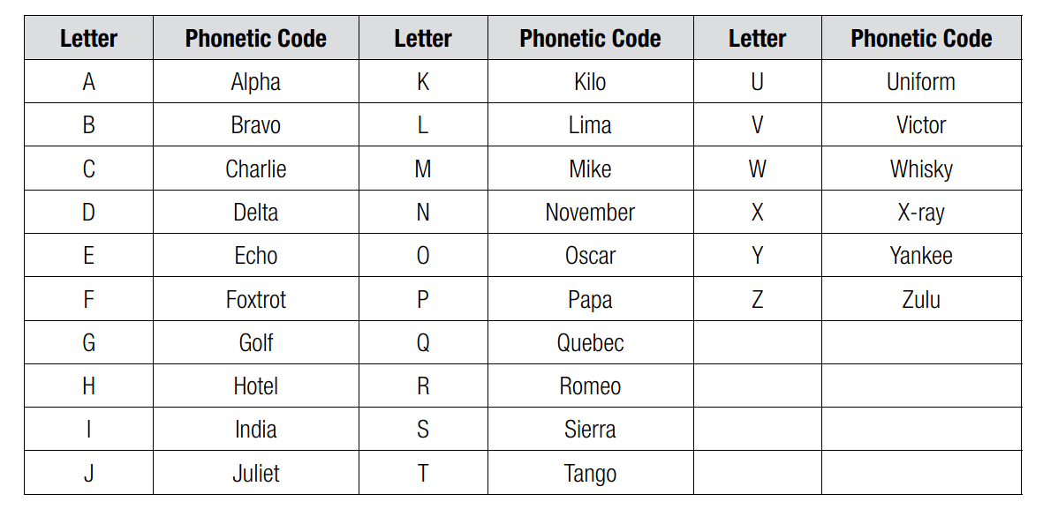
For example: Tour code: JA800 = Juliet / Alpha 800

The 24-hour clock
The 24-hour clock is used in the travel industry throughout the world. In particular, the times in your CRS system are represented by the 24-hour clock and both domestic and international tickets are issued using the 24-hour clock. It is represented with four digits.
For example:
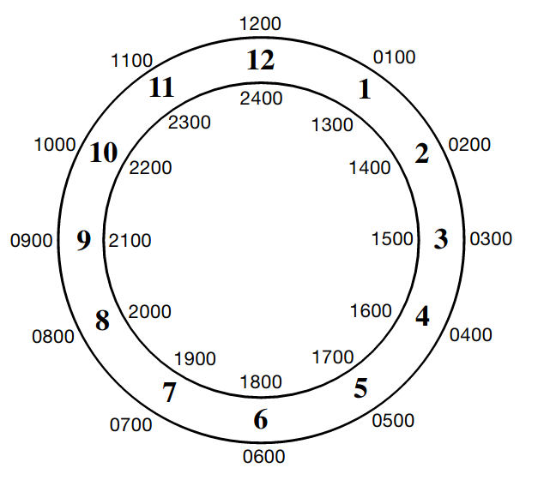
Airport city codes
Three letter codes are used for all cities and airports throughout the world. The city and the main airport will often share the same code, however this is not always the case (e.g. LON = London and LHR = London Heathrow Airport).
Your CRS/GDS system is used to encode or decode cities and airports. There are also websites which offer city/airport, decode/encode facility.
The following are the codes for the top 30 major international airports with most passenger traffic.
Rank | City and Map | Airport | Country | IATA  Code
1 | Atlanta; GA | Hartsfield-Jackson Atlanta International | USA | ATL
2 | Beijing | Beijing Capital International Airport | China | PEK
3 | Chicago; IL | Chicago O'Hare Airport | USA | ORD
4 | London | London Heathrow | United Kingdom | LHR
5 | Tokyo | Haneda Airport | Japan | HND
6 | Los Angeles; CA | Los Angeles International | USA | LAX
7 | Paris | Paris-Charles de Gaulle Airport | France | CDG
8 | Dallas/ Fort Worth; TX | Dallas/Ft. Worth International | USA | DFW
9 | Frankfurt | Frankfurt Airport | Germany | FRA
10 | Denver; CO | Denver International | USA | DEN
11 | Hong Kong | Hong Kong International Airport | Hong Kong | HKG
12 | Madrid | Adolfo Suárez Madrid-Barajas | Spain | MAD
13 | Dubai | Dubai International Airport | United Arab Emirates | DXB
14 | New York; NY | John F. Kennedy International | USA | JFK
15 | Amsterdam | Amsterdam-Schiphol | Netherlands | AMS
16 | Jakarta | Soekarno-Hatta International Airport | Indonesia | CGK
17 | Bangkok | Suvarnabhumi Airport | Thailand | BKK
18 | Singapore | Singapore Changi International Airport | Singapore | SIN
19 | Guangzhou | Guangzhou Baiyun International Airport | China | CAN
20 | Shanghai | Pudong International Airport | China | PVG
21 | Houston; TX | George Bush Intercontinental | USA | IAH
22 | Las Vegas; NV | McCarran International Airport | USA | LAS
23 | San Francisco; CA | San Francisco International | USA | SFO
24 | Phoenix; AZ | Sky Harbor International | USA | PHX
25 | Charlotte; NC | Charlotte Douglas International Airport | USA | CLT
26 | Rome | Leonardo da Vinci-Fiumicino Airport | Italy | FCO
27 | Sydney | Sydney Airport | Australia | SYD
28 | Miami; FL | Miami International Airport | USA | MIA
29 | Orlando; FL | Orlando International | USA | MCO
30 | Munich | Munich International Airport | Germany | MUC


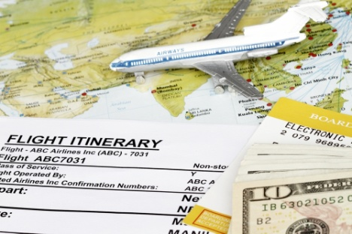
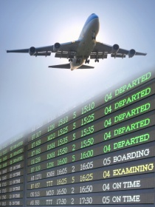

Activity 12 - Identify key ASEAN Airport codes

You are to identify the different airport codes for the following ASEAN countries.
COUNTRY | CITIES | AIRPORT CODE
Brunei
Cambodia
Indonesia
Laos
Malaysia
Myanmar
Philippines
Singapore
Thailand
Viet Nam


Airline codes
Airlines have two letter alpha airline codes. Here are some global examples.
Airline Code | Airline
AA | American
AC | Air Canada
AF | Air France
BA | British Airways
CA | Air China
CX | Cathay
CZ | China Southern
EK | Emirates
JL | JAL
KE | Korean
MH | Malaysia
MU | China Eastern
NH | ANA
NW | Northwest
OZ | Asiana
PR | Philippine
QF | Qantas
BI | Royal Brunei Airlines
SA | South African
SQ | Singapore
TG | Thai
TK | Turkish
UA | United
VS | Virgin Atlantic

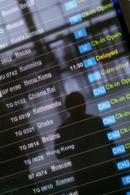

Activity 13- Identify key ASEAN Airline codes

You are to identify the different airline codes for the following ASEAN countries.

COUNTRY | NAMES OF AIRLINES | AIRLINE CODES
Brunei
Cambodia
Indonesia
Laos
Malaysia
Myanmar
Philippines
Singapore
Thailand
Vietnam

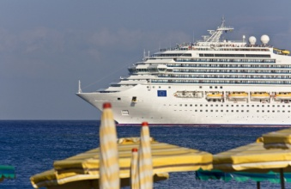
Cruise ship terminology
The following terms are commonly used when dealing with cruises.

Term | Definition
Aft | Toward the stern (back)
Adjoining cabins | Cabins that are next to one-another
Berth | The bed or beds within the cabin
Bow | Front of the ship
Bridge | Ship’s navigational control centre
Cabin | Room on a ship
Captain | Person in command of a ship
Category | Price gradient cabins from the most expensive to the least expensive
Deck plan | Diagram illustrating cabin and public room locations in relation to each other
Disembark | Exit from the ship
Double occupancy | Cabin shared by two people
Embark | Board the ship
Free style | No set meal times
First sitting | Earlier of two meal times, usually around 1800 hours
Forward | Toward the front of the ship
Gangway | For embarking or disembarking from the ship
Gratuities | Passenger expression of thanks to the ships service personnel for services
Inside cabin | A cabin with no window, or porthole
Lower berth | Bed of a cabin located on the floor
Midship | Towards the middle of the ship
Outside cabin | A cabin having with a porthole, or window
Port | The left-hand side of a ship as one faces forward
Second sitting | Later of two meal times, usually around 2000 hours
Shore excursions | Sightseeing tours, or activities offered while at a port-of-call
Stern Rear end of ship | Rear end of ship
Steward | Person who looks after the passengers aboard
Starboard | The right-hand side of a ship as one faces forward
Suite | A cabin and a sitting room area
Sole use | A cabin occupied by one passenger
Ports of call | Stopovers on a cruise itinerary
Purser | A ship’s officer in charge of money and accounts
Private facilities | A cabin with its own bathroom facilities
Tax and port charges | Additional charges to help defer the docking fees charged by the port or country
Quad cabin | A cabin that accommodates four passengers
Upper berth | The top (bunk) bed in a cabin


Tours terminology
The following terms are commonly used when dealing with tours.

Term | Definition
2nd Tour discount | Discount for booking another tour
Baggage handling | An additional cost used for tipping
BB | Meal code for included buffet breakfast
CB | Meal code for included continental breakfast
Cost per day | The total cost of the tour divided by the number of tour days
D | Meal code for included dinner
Early bird Special | Discount for booking and/or paying early
Escorted | A company representative accompanies the tour
Food kitty | Payment paid to cover food on tour
Guaranteed departures | Regardless of numbers the tour will depart
Guided tour | A tour which has a tour guide
Hotel list | List of hotels to be used on tour
Inclusions | What is included
L | Meal code for included lunch
Local guides | Specialist guides engaged in particular places
Option date | Date by which the deposit must be paid
Optional tour | Not included in tour price – extra
Past passenger discount | Not a first time passenger with this company
Pre accommodation | Accommodation before the tour
Post accommodation | Accommodation after the tour
Price guarantee | Once fully paid the price cannot increase
Room matching | Tour Operator will share single passengers
Seat rotation | Process of daily rotation of passenger seating
Single supplement | Additional amount to be paid for single accommodation
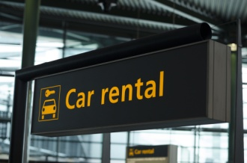

Car hire terminology
The following terms are commonly used when dealing with car hire.

Term | Definition
Accessories | Baby seat, roof rack, snow chains etc
Air con | Air conditioning
Additional driver | Additional to the main driver
A day’s car hire | A 24 hour period
Airport taxes & fees | Payable for airport pick-up/drop-off
ALI | Additional Liability Insurance
Berth | Sleeping accommodation in motor homes
Bond/Deposit | Amount held pending return of the vehicle in the same condition as rented
CDW | Collision Damage Waiver insurance
Daily rate | Price per day for car hire
Depot | Place to pick-up and drop-off
Drop-off | City and depot to return car
ER | Optional excess reduction charge to waive or reduce excess
Excess | The amount to be paid in the event of an accident (covers your vehicle and other vehicle)
Extra’s | Not included in rental and pay locally when vehicle is collected
Floor plan | Lay-out of motor home
GPS | Global Positing System
Late return charges | Payable if vehicle not returned on time
Leasing | Long term rental of ‘new’ vehicle
LDW | Loss Damage Waiver
Limited mileage | Charged for distance travelled
Long term rate | Price for rental over a specified period
Manual/Automatic | Manual or Automatic transmission
MAX PAX | Maximum passengers
Never lost | Global Positioning System
One way fee | Fee imposed to cover the cost of returning the vehicle back to the pick-up location
One way rental | The pick-up and drop-off cities are different
PAI | Personal Accident Insurance
PEC | Personal effect cover
Petrol/Diesel | Type of fuel
Pick-up | City and depot to collect car
Premium location surcharge | Applied for selected downtown and railway locations
Rental period | The period from date & time of collection to date & time of drop-off
Senior driver surcharge | Payable by drivers over a specified age
Theft protection | Insurance against theft of vehicle or vandalism
Third party | Provides cover against injury of people other than the driver of the rented vehicle
Unlimited mileage | Not charged for distance travelled
Weekly rate | Price per week for car hire

Rail travel terminology
The following terms are commonly used when dealing with rail travel.

Term | Definition
A rail travel day | Midnight to midnight
A rail travel month | A calendar month
Accessible room | Compartment for wheelchair passengers, two beds, private bathroom including toilet, shower and basin
Bedroom | By day a reclining sofa and arm seat, by night an upper and lower bed with private facilities
Child pass (Britrail) | Children aged 4-11 years inclusive travel free when not occupying a seat (if under 4 years of age)
Child pass (Eurail) | Children aged 5-15 years inclusive
Consecutive pass | Used over consecutive days
Couchettes (Europe) | Open bunks in a compartment, which accommodate four or six passengers
Duration | How many days the pass can be used
Eligibility | Who can purchase the product
Family bedroom | Compartment for families. Reclining seats which convert to two upper and two lower beds. Sleeps two adults and two young children per compartment
Flexi pass | Used on a specified number of days
Hotel trains (Europe) | Offer the privacy of hotel style rooms
Party pass | Discount available when 3-9 passengers travel together on all sectors
Point to point tickets | Travel along the same route from one point to another point with stopovers permitted along that same route
Roomette | A comfortable reclining seats which converts to an upper and lower bed at night
Sleepers | Bedroom which accommodate up to four people
Sleeperette | Usually a reclining seat, similar to aircraft seating
7pm rule | Travel after 7pm must enter next day on the pass
Validity | When the pass can be used

Accommodation terminology
The following terms are commonly used when dealing with accommodation.

Term | Definition
Double (DBLB) | Two people sharing a room with a double/queen/king bed provided
MAX PAX | Maximum people allowed in the room
Roll away | Extra sleeping accommodation which is rolled away during the day
Run of house (ROH) | Passengers will be allocated the most suitable room type upon check in to the hotel
Sole use | One person using the room only
Season | The date range applicable to a particular rate
Split season cost | This applies when a client’s stay is spread over different seasons
Twin share (TWN) | Two people sharing a room with two single or double beds provided
B&B | Bed and breakfast
BBP | Bed and breakfast provisions
BCB | Bed and continental breakfast
Check-in time | The earliest time the passengers may check-in to the room
Check-out time | The latest time the passenger must check-out of the room
Late check-out | Where the check-out time is extended FOC or it has been pre-booked and pre-paid
Late arrival | Usually an arrival after 1800 hours
Credit card guarantee | Credit card number provided to hotel in order to hold the room
Hotel Club | Loyalty program

Insurance terminology
The following terms are commonly used when dealing with insurance.
Term | Definition
Limits | Special conditions applying to people of a certain age
Duty of disclosure | Passengers must disclose all relevant details for the cover to be valid
Eligibility | Who is eligible for cover
Emergency assistance contact | The contact number to call in the event of an incident requiring assistance from the insurance company
Excess | The amount to be paid for each claim arising under the policy
Exclusions | What is not covered
PDS | Product Disclosure Statement
Premium | The amount paid for the policy
Pre-existing medical conditions | Medical conditions existing at the time of policy issue
Specified item | Items for which specific cover is required



Activity 14 - Interpret travel brochure

Access a brochure from a tourism operator and answer the following questions:
What is the destination of the product?
__________________________________________________________________________________________________________________________________________________
What is the package being promoted?
__________________________________________________________________________________________________________________________________________________
What information about the destination is provided?
__________________________________________________________________________________________________________________________________________________
What general information is provided?
__________________________________________________________________________________________________________________________________________________
What accommodation is offered?
__________________________________________________________________________________________________________________________________________________
What is the itinerary?
__________________________________________________________________________________________________________________________________________________
What are the departure dates?
__________________________________________________________________________________________________________________________________________________

What are the inclusions/exclusions?
__________________________________________________________________________________________________________________________________________________
What is the price of the package?
__________________________________________________________________________________________________________________________________________________
What are abbreviations or codes that need to be explained to the client?
__________________________________________________________________________________________________________________________________________________
Summarise the conditions of the package
__________________________________________________________________________________________________________________________________________________
Interpret travel documentation
Besides having to interpret industry terminology, it is essential that you also understand the different types of travel documentation that will be used, either by the organisation or given to customers, as part of the travel experience.
Travel documentation will be related to:
- Non-air documentation
- Air documentation.
Non-air documentation
Non-air documentation may include:

- Accommodation vouchers
- Bus/coach or other forms of transportation tickets
- Car hire/motor home vouchers
- Cruise vouchers
- Tour vouchers
- Vouchers for attractions/theme park entry
- Vouchers for any tourism product or service
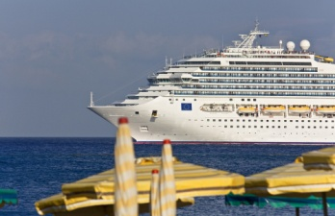
- Meeting or event confirmation letters
- Delegate information packs
- Travel insurance documentation
- Confirmation vouchers
- Visa forms
- Visas
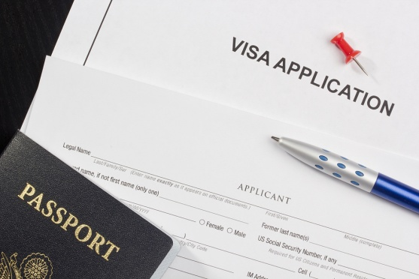
- Passport forms
- Traveller’s cheque requests
- Passenger itineraries
- Operational itineraries for crews including tourist guides, drivers and tour managers
- Briefing notes for crews
- Passenger lists
- Rooming lists
- Pro-formas
- Sales returns.
Air documentation
Air documentation may include:

- Tickets
- Miscellaneous charge orders
- Credit card charge forms
- Exchange tickets
- Reservation alterations and re-validation stickers
- Pre-paid ticket advices.



Activity 15 - Identify travel documents

Based on the trip selected in Activity 2, identify the types of travel documentation you would need to prepare or present to the client.

NON AIR DOCUMENTATION
Type of documentation | Key points to communicate with clients

AIR DOCUMENTATION
Type of documentation | Key points to communicate with clients

4.2 Pass on general information relating to products and services

Introduction
Once the final quotation has been confirmed, with staff understanding all necessary terminology and documentation that makes up the travel quotation of booking, it is now time to present the information and relevant documentation to the customer.
One of the first steps in this process is to identify the best method in which to get the information to the customer.

Given that a travel company now can reach customers in all corners of the globe, through electronic communication and social media, in many cases the traditional method of face to face meetings may not be possible.
Whilst face to face contact is still the most preferred method, there are many submission methods that can be used to suit the needs of both the customer and travel agent.

Submission considerations
There are a number of considerations that must be taken into account when selecting the most appropriate submission method.
Some considerations include:
- Location of the customer – naturally if the customer is not located in your area, the concept of face to face discussion is not possible
- Number of persons to receive quotation – when preparing information for business purposes or for a number of travellers, the information may need to be sent to many persons in different locations

- Reliability of submission methods – depending on the region, some submission methods, such as mail, may be unreliable and quite simply take too long to get to the customer
- Types of documentation required – if the quotation also contains reference materials such as brochures from product and service providers, mailing of documents may be the most preferred method
- Time frames required – in the event of immediate travel, electronic communication will be the most desirable submission method as it is instantaneous
- Costs – naturally there is great cost associated in mailing proposals on a regular basis. Depending on the organisational requirements, initial quotations may be sent electronically, as it is the most cost effective method of submission.

Customer service basics when presenting information
It is a fundamental requirement that staff attempt to create sales out of quotations and other related information as opposed to simply preparing quotations.
When presenting information customer service essentials include the need to:
- Have comprehensive product knowledge

- Remember to consider customer needs, wants and preferences and suggest only those products and services that meet these identified criteria
- Ask questions – to gather information from the customer to identify if the quotation meets their needs, wants and preferences and to clarify related issues
- Be proactive – that is, you need to be able to initiate interaction with customers rather than wait for them to come to you and ask a question or make a purchase
- Provide information, recommendations, advice and suggestions that aligns with identified customer need
- Sell the benefits of products and services – as opposed to simply stating the features of the products and services
- Overcome objections by customers to making a purchase – by identifying the root cause for the objection and then applying acceptable problem-solving techniques

- Allow customers time and opportunity to consider their purchase – as opposed to rushing them, pressuring them or intimidating them into buying
- Make legitimate all add-on/complementary sales – to optimise the value of the sale and providing what the customer wants without pressuring the customer
- Close the sale – as opposed to allowing the customer to continually ‘think about it’ and eventually decide not to purchase.
It is important to remind yourself of them as the role of providing quotations in person is just more than passing over a piece of paper.

Considerations when providing quotation information
When you provide information to customers it is absolutely essential that is it:
- Up-to-date

- Accurate
- Comprehensive – make sure you tell the customer about any ‘less than attractive elements’ of what you recommend
- Honest
- Straight-forward and easily interpreted and understood
- Concise – you certainly don’t want to give customers the impression you are rushing them but you also need to be sensitive to:
- Their need to ‘get going’
- Your need to get on with other work and serve other customers.

Process of explaining and expanding on the quotation
When communicating product information, it is vital that the audience understands what is being introduced and explained to them.
The process of explaining and expanding on quotation information has some vital elements that must be covered, including:
These concept aspects can therefore include:
- Details about physical products - where they are made, their characteristics, their price and availability, how to buy those products
- Information about the services that are available – including who provides the service, when it is available, how much it costs, what it involves, what it is like and how to book it
- Information on prices, Specials, deals and packages – being able to explain how these benefit the customer, what savings they involve, when they are available, when the offer finishes, who is eligible for them and how to obtain them

- Providing personal interpretation and explanation of the quotation
- Providing supplementary information as required
- Explaining the reasons for charges and fees included in the quotation
- Assisting the client to understand the reputation and expertise of nominated suppliers, providers and carriers
- Providing supporting brochures and marketing materials to assist with understanding of the quotation.

Information submission methods
Information is provided to customers in one of the following ways:
- Verbal explanation
- Provide hard copy materials
- Provide electronic materials.

Verbal explanation
Whilst you as the travel agent may have spent considerable time researching and developing a quotation for a customer, it is important to remember that the customer may have only seen an initial quotation.
Also it is important to remember that customers do not have the same degree and depth of knowledge in the travel industry and the processes involved in making bookings, and that they will need explanation from yourself to help their understanding.
Benefits of providing a verbal explanation
- Explain in more detail the key pieces of information in them

- Answer any questions customers may have
- Provide suggestions and recommendations
- Outline the processes associated with confirming and organising travel arrangements
- Guide them through the sales process.

Providing hard copy materials
Another effective method of providing information is through the distribution of hard copy materials. This method may be used as an individual activity or in conjunction with other information delivery methods.
Benefits of providing hard copy materials
There are a number of benefits of distributing hard copy information to potential audiences including:
- Utilises an additional learning method - as opposed to listening to a presentation
- Provides comprehensive information
- Provides appealing images

- Provides information in its intended message
- Enables the audience to review information at their own time and at their own pace
- Enables information to be reviewed on multiple purposes
- Enables the audience to show other people information as well
- Enables audience to become familiar with content before subsequent verbal presentations and meetings.
Types of hard copy materials
There are endless hard copy materials that can be provided including:
- Reports
- Brochures

- Quotations
- Invitations
- Travel itineraries
- Handouts
- Fact sheets
- Notes
- Photocopies from policy manuals
- Texts

- Media articles
- Photographs
- Posters
- Flyers
- Marketing materials
- Financial statements.

Providing electronic materials
Sending electronic materials is the most common way of sending information to various stakeholders and customers.
Benefits of distributing electronic materials
There are a number of benefits of distributing electronic information to potential audiences including:
- Information can be shared instantaneously
- It guarantees the intended audience receives the information, unlike mail which may go missing
- It enables the sender to see who has received and read the information
- Information can be sent to numerous people

- Information can be sent securely enabling information to remain confidential
- It can be distributed to people around the world, regardless of location
- It is a cost effective method of distributing information
- It reduces storage space required for hard copy documents
- it can be stored in shared 'cloud' systems for access by many people
- Information stored in electronic systems can be updated easily.

Types of products and services information to communicate
In summary product and services information to explain to customers may include:
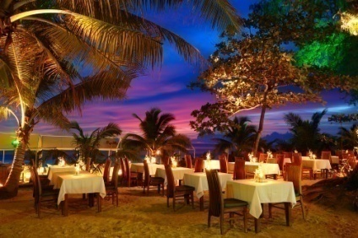
- Transportation and transfers
- Accommodation, meals, functions and entertainment
- Tours, cruises and entry to attractions
- Tour guide services and activities
- Special events, including special event consumable items
- Venue and convention facilities, including equipment to support same
- Speaker, audio-visual, catering, health and financial services.

Examples of products and services information to communicate
In Section 1.1 of this manual different pieces of information accessed in relation to different products and services, provided by different businesses in the travel and tourism industry have been identified.
That said, common information commonly communicated with customers include, but not limited to:
Flights

- Airline details
- Destinations and routings
- Class of travel
- Departure and return dates – remember to include the year
- Fare validity – for sale and for travel dates
- Air fare per person
- Taxes per person (always state that these are subject to change).
Accommodation

- Name of accommodation and location
- Room type and bedding configurations
- Check-in and check-out dates
- Total number of nights
- Any extras or inclusions such as meals, transfers etc
- Cost per person per night and total amount for the stay.
Car hire/Rentals
- Name of company they are using – Avis, Budget, Hertz etc

- Vehicle group or type – compact, midsize, group C etc
- Transmission – manual or automatic
- Pick up and drop off dates, times and location
- Rate – if paying direct
- Rental Inclusions – mileage, additional drivers, insurances, taxes
- Any additional local payments for additional services e.g. GPS.

Cruises
- Name of the cruise line or company
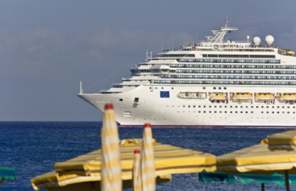
- Name of the ship
- Name of cruise, including code
- Number of days or nights
- Departure date, time and location
- Return date, arrival time and location
- Cabin type and deck location.
Tours
- Tour company name
- Tour name, code and duration
- Departure date, time and location/city
- Arrival date, time and location/city
- Rooming details – single, twin, triple

- Inclusions.
Transfers
- Date, time and location of transfers
- Type of transfer – seat in coach, private transfers, limousine etc.
Insurance
- Company used
- Policy type and length of policy
- Type of cover
- Reference to PDS (Product Disclosure Statement).

4.3 Explain specific details about product and services

Introduction
In the previous section, general information relating to products and services required by customers have been identified.

Whilst the information provided will be related to the type of travel experience sought by customers, there is other specific information that needs to be communicated with customers.
This additional information will normally relate to the policies, procedures, terms and conditions associated with booking the products and services themselves.
Given that different suppliers of tourism products and services will have their own terms and conditions, it is essential that customers are aware of any conditions or limitations that may affect their travel experience.
Types of specific details
Regardless of the tourism products and services requested by customers the range of specific details that must also be explained to the customer include:
- Seasonality
- Availability & Confirmation
- Costing considerations
- Additional travel costs
- Product price increases
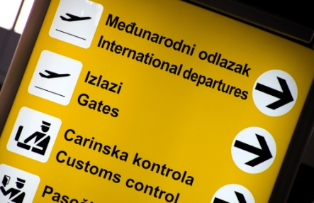
- Fluctuations in exchange rates
- Booking conditions
- Terms and conditions
- Scheduling information
- Product codes
- Booking procedures
- Points of departure and arrival
- Touring inclusions and exclusions
- Technical specifications for audio-visual and other meetings and events equipment
- Travel insurance
- Limitations
- Safety and risk – adventure products
- Non operation of the product – tour cancellation.
This section will explore some of the specific details that are common to all travel experiences.

Seasonality
Several products and services, in particular airfares and accommodation establishments, may be subject to price variances based on seasonality. Simply, this means that the date of the product or service utilisation determines the price. Examples are:
- Airfares – the date of departure often dictates the fare to be charged
- Hotels – surcharges may apply for weekends
- School holiday periods – demand is high and therefore higher rates usually apply.

Normally the calendar year is divided into various date ranges and labelled and priced accordingly. Some examples:
- High season – most expensive
- Should season – in between
- Low season – least expensive.
Seasonality is not limited to these three categories.
Accommodation may cross over seasons. Caution should be exercised when quoting from a brochure based on the check-in date. There are many instances where the check-in date may be in low season however there are nights which cross over into either shoulder or high season and where the price for those nights will be different.
It is also good practice to make sure that the brochure prices are still valid. It can be challenging to work out the cost of a number of nights over two or more seasons. Contact the supplier for assistance.

Availability & Confirmation
All quotes should be provided subject to availability. Never assume that a product or service will be available.
Make sure that the customer understands that notification to you that they wish to accept the quotation and proceed with a booking, does not constitute a confirmed booking. The booking is only confirmed once you have made contact with the service provider and you have received confirmation in writing. Only then are you in a position to provide a verbal, or preferably, a written confirmation to your passenger.
The confirmation should, minimally, detail:

- What has been booked and confirmed
- Who it has been booked for (the full name)
- The terms and conditions
- Deposit and payment amounts (dates due)
- Acceptable forms of payment
- Credit card merchant fees.

Costing considerations
There are a number of factors that influence variations in costs of travel products and services, including:
- Seasonality – high, shoulder, low or peak, off peak or combinations
- Validity dates – what prices apply to what dates
- Date of booking
- Date of travel

- Surcharges – weekend stays, extra bedding
- Restrictions – age, student, senior, nationality, validity of driver licence
- Standard – Luxury, moderate, standard, basic, budget, backpackers
- Inclusions/exclusions – meals, sightseeing, entrance fees, tour escort
- Bedding – single, twin share, triple, quad, multi, dormitory
- Child and infant costs – when is a child a child and when is an infant an infant
- Currency used and conversion rates
- Payments – early bird payments, instance purchase tickets
- Conditions of sale – book by for travel by
- Packages versus single items sold
- Stay Pay – stay 4 nights and pay for 3 nights
- Last minute deals and spot specials – used to fill remaining seats, rooms or cabins.

Additional travel costs
Apart from the detail of the actual products and services and the applicable prices, there are other costs that must also be explained to customers including:
- Mandatory organisation service, transaction or planning fee etc

- Insurance - see below
- Visa – are they required and how much will they cost?
- Airport taxes
- Merchant fees – most credit cards incur these fees which are between 1-4%
- Any taxes and levies which are payable direct and which are not included in the quotation
- Extra charges such as hire of GPS, baby seat, child booster, snow chains, roof rack, rollway bed, baby cot charge etc
- Exchange rate fluctuation – if applicable.

Common ways to publish costings
Tours | Per person twin share
 | Single supplements usually apply for single passenger
Accommodation | Per person per night twin share
 | A sole guest will pay twice the twin share rate i.e. room rate
Car rentals | Per day which is equal to one 24 hour period
Transfers | Per person per one way transfer – seat in coach/ferry/bus
 | Per car or limousine per one way transfer
Cruises | Per person per cabin twin share
 | Sole use of a cabin will be priced higher than the twin share price
 | Port charges and taxes
Rail | Tickets – per person per one way/return journey
 | Passes – per person per pass

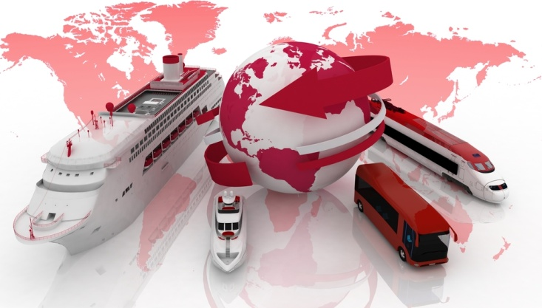
Product price increases
Regardless of the price of the product at the time of purchase, there is always a risk that due to particular circumstances that the price may increase even after the booking has been deposited or rarely, after it has been fully paid.
The most common reason for this is the devaluing of local currency against other foreign currencies. The best protection against these types of increases is to pay in full. Most wholesalers/suppliers will NOT increase the price of a particular product if they have received full and final payment for the applicable arrangements.
Often where an increase is about to be applied, passengers who have booked and paid a deposit, will be given a time limit by which they need to pay in full to avoid the increase. This however may not always be the case.
Increases to airline bookings do not apply once the air ticket has been issued and provided that once issued, there are no changes. However until that time, airline bookings are particularly vulnerable to price increases due to:

- Expiration of the airfare
- Interpretation of airfare rules by the consultant
- Missed ticket deadline
- Change in taxes and levies
- Fuel surcharges.
It is important therefore that passengers are made aware that:
- Taxes and levies can and do vary and are only firm once the ticket is issued
- Until the air ticket is issued, the price may change
- Changes to the bookings may change the price
- Cancellations and amendments, after ticket, issue will incur fees.

Fluctuations in exchange rates
There are some products that, while quoted in local currency or United States Dollars (USD) to the Travel Agent and subsequently to the customer, are in fact bought and sold in a foreign currency. This necessitates the conversion of the foreign currency amounts into local currency. The rate used for the conversion can and does vary as the value of the local currency will vary against other currencies on a daily basis.
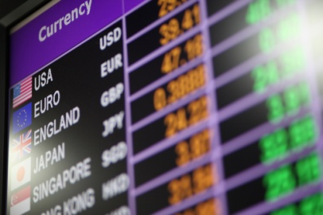
Where you have received and are providing such a quote to customers, it is vital that this is explained in full.
Further, notice of currency variations resulting in a higher or sometimes lower price must be given in writing. An example of what you may see on a quote from a supplier or operator:
Due to the current economic climate, all prices quoted are subject to currency fluctuations until paid IN FULL.
Prices quoted more than 7 days prior to final payment will be re-assessed at the rate of exchange on the day of payment. This will mean that an increase or a reduction in price may occur at the time of final payment. Once final payment is received the holiday price will no longer be subject to currency fluctuations in either direction.
Where the potential for price changes exist due to currency fluctuation, many travel organisations will have standard wording which must be reflected on all company correspondence to customers.

Booking conditions
Common booking conditions include:
- How to book – who to contact
- Amount of deposit required
- Prices and validity
- Assumption of risk
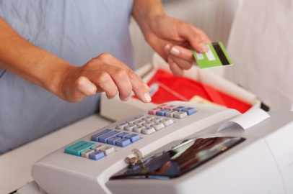
- Exclusion of liability
- Payment deadline
- Ticketing deadline
- Extension ticketing deadline
- Cancellation by the supplier
- Force Majeure
- Cancellation by the travel agent
- Cancellation charges
- Availability of any type of change to booking
- Availability of changes to class of booking
- Types of booking amendments
- Amendment fees

- Complaints
- Authority of suppliers and tour leaders
- Baggage allowance
- Excess baggage charges
- Health, fitness and age limits
- Publicity
- Privacy
- Governing law.

Deposit, payment and cancellation terms and conditions
In the travel industry, there are always terms and conditions associated with the various products and services.
It is vital that both you and your passengers are aware of the particular terms and conditions in relation to the various products and services that are being considered and/or booked.
These terms and conditions are usually comprehensive, detailed, cover almost every eventuality and should be read and understood by all parties. Most terms and conditions are located:
- In the brochure – back pages
- Online.
If for any reason you cannot locate the terms and conditions, do not assume that they do not exist. You must contact the supplier and check.
All quotations will come with terms and conditions that will apply to various aspects of travel arrangements.

Terms and conditions may be provided by:
- The travel agent themselves
- Suppliers
- The individual product or service provider.
You are strongly advised to refer to these terms and conditions when providing a quotation for your customer.
It is essential that any terms and conditions are clearly identified and that customers understand them.

General terms and conditions
Whilst there may be an endless set of terms and conditions that may be established, to suit the needs of the respective suppliers and providers, taking into account organisational requirements and the nature of their services, there are common terms and conditions that relate to most travel related quotations.
General terms and conditions include:
- Terms and methods of payment, including dates for payment of deposits and final payment

- Notifications regarding final confirmation of the booking and, where relevant, numbers
- Cancellations and penalties and charges that apply
- Procedures and charges that apply to name and date changes for the booking
- Guarantees and warranties that apply to the products and services covered by the quotation
- Age limits
- Health and fitness requirements
- Exclusion and limitation of liability clauses
- Identification of the period for which the quotation is valid
- Whether or not the quotation is subject to change with or without notice
- Reference to associated terms and conditions as imposed by third party providers
- General industry rules, regulations and codes.
Travel Agent Terms and Conditions
Each product or service included in the quotation will have a set of general conditions which will be provided to you by the wholesaler or operator that you are utilising.
They will commonly include terms and conditions relating to:

- Deposit and how to book
- Payment Options
- Amendments
- Final Payment
- Cancellations and refunds.

Following is an example of travel agent terms and conditions.

TRAVEL AGENT – TERMS AND CONDITIONS
For full terms and conditions relating to our products and services, please refer to the full terms and conditions as outlined in our brochure and on our website.
Deposit and how to book
In order to place a reservation, a non-refundable deposit of $250.00 per person is required. Bookings made within 45 days of departure will require full payment at time of placing the reservation.
Receipt of the deposit indicates to our organisation that the traveller has agreed to their confirmed travel arrangements. Deposits paid are non refundable.
Payment Options
• Cheque
• Smart Money
• Money Direct
• Credit Cards – AMEX VISA MASTERCARD + Merchant Fee
• Direct deposit
Amendments
Should the reservation be altered after the original booking has been confirmed a fee of $150.00 per amendment will be applied to cover additional administrative and communication costs.
Depending on the nature of the change, seasonal price adjustments, additional costs or cancellation fees may also be applicable.
Final payment
Full and final payment is required no later than 45 day prior to departure.
If payment is not received by the due date, our organisation reserves the right to treat the booking as cancelled and will apply full cancellation charges as specified
Cancellation and refunds
Cancellation fees for some programmes may vary from those stated below. Please check at the time of booking. If the reservation is cancelled the following per person fee will apply:
• Up to 45 before departure loss of deposit
• Between 45-30 days up to 50% of total cost
• Within 30 days of departure up to 100% of total cost
• After departure no refund for any unused service
All costs are subject to alteration and currency fluctuation without notice, up to and until full and final payment is received.

Supplier terms and conditions
It is important that all supplier, wholesaler, operator conditions are highlighted to the customer together with your own travel agent terms and conditions.
Here is an example of a standard travel agent attachment. These, or a similar document are routinely used as an appendix to written or email quotations or as a hand out for customers.

SUPPLIER – TERMS AND CONDITIONS
Validity
All quotes provided are valid for 7 days from date of issue and are subject to availability and change.
Car Hire
Car hire companies will require a credit card deposit and/or guarantee upon pickup of vehicle.
Hotel Check In/Out
Most hotels have a check in time of 2pm and check out time of 10am. Should you wish to arrive or depart outside of these times, a room may only be allocated to you subject to availability.
Flight Schedules
Flight schedules are subject to change. We will endeavour to notify you as soon as possible if your itinerary is affected, but please be aware that changes are out of our control.
Amendment and Cancellation Fees
Cancellation charges can be up to 100% depending on the reason for and time of cancellation. Please refer to the terms and conditions in the brochures provided.
The operator will impose cancellation and amendment fees and we strongly suggest you peruse these conditions carefully. In addition, depending on the rules and conditions of the airfare purchased, the airline will charge cancellation and amendment fees.
Insurance
Travel insurance is strongly recommended for medical, cancellation and unforeseen circumstances. Please carefully read the conditions and inclusions of your selected policy, so you know you have adequate cover.
Taxes
Most countries now require taxes to be paid in advance. Any taxes already paid are detailed in your above costing. They are however subject to change at any time prior to the air ticket being issued.

Product or service provider terms and conditions
Individual product or service providers will often have a set of terms and conditions relating to their particular product or service.

These will cover, among other items:
- Pricing policy
- Payment conditions
- Inclusions
- Exclusions
- Any restrictions or limitations.
As can be seen in this section there are many terms and conditions provided by various organisations involved in the travel booking process.
Naturally the extent and finer details or terms and conditions may seem overwhelming or not anticipated by the end user. Therefore the role of travel agents in ensuring customers understand them is a vital aspect of providing quotations.

Travel insurance
Travel insurance should always be recommended to passengers to protect against a range of situations, most commonly:
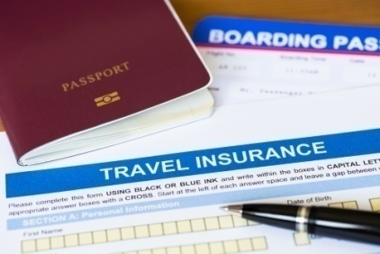
- Cancellation fees
- Medical and/or dental expenses
- Personal liability
- Accidental death, disability or loss of income
- Emergency travel arrangements e.g. repartition
- Loss or damage to personal items – luggage, camera, travel documents.
The premium charged will depend on the type of policy required and this depends on many factors, some of which follow:
- Destination and duration
- Purpose of the trip
- Level of cover required
- Age of the passenger
- Excess selected
- Existing medical conditions.
Travel to some countries e.g. United States of America will attract higher premiums due to the high level of cover required for medical expenses.
Similarly, passengers over a certain age or who require cover for existing medical conditions will be subject to a surcharge. Application for this type of cover requires the completion and submission of forms to the insurance company for evaluation.

Every insurance company will have their own particular processes in relation to approval for cover for aged passengers or pre-existing medical conditions. In general however the policy cannot be issued without formal written approval from the insurance company and an approval code which must appear on the policy.
Some insurance policies will exclude claims based on situations such as terrorism and act of God etc. It is important that your client is provided with a brochure which contains all the information in relation to the policy that they are considering purchasing called a Product Disclosure Statement (PDS).
Travel Agents must be in receipt of a completed and signed application form before they can proceed to issue an insurance policy. In completing and signing the form, passengers agree that they have read, understood and agree to the conditions of the policy and that they have fully disclosed all relevant information in relation to the issuance of the policy.
If insurance is offered and then declined by the passenger, it is always a good idea to get this in writing. This is standard procedure in some organisations.
There are a range of companies who offer travel insurance and some of the ones most often used in the travel industry, appear at the back of this book.
Travel Agents act only as an agent for the insurance company and they are not insurance agents. That said, in order to sell travel insurance, travel consultants are required to complete company specific training which in most instances is made available on-line via the various companies. Usually, the sales representative for the insurance company will also provide in-house training for consultants.
Each company will have a specific process that passengers are required to follow in the event of a claim, detailed in the PDS, however in general passenger should:
- Report the incident to the appropriate authority in the country of occurrence
- Retain all paperwork e.g. reports and receipts
- Advise the insurance company in writing ASAP after the event.
While Travel Agents may provide the passengers with the applicable claim form and supporting documentation e.g. invoice for cancellation fees, it is the passenger who completes and submits the paperwork directly to the claims area of the insurance company.
The Travel Agent should not make judgements in relation to the validity of a claim. These matters are entirely between the passenger and the applicable travel insurance company and their claims area.


Limitations
Particular products may have stated or self-evident limitations. Awareness in relation to these particular products, your clients’ needs and potential limitations is always a consideration when making recommends.
Typically these relate to age, fitness or disability. Some examples:
- Contiki Tours - only passengers aged 18-35 years old

- Evergreen Tours - primarily mature aged and seniors
- Peregrine’s trekking in the Himalayas - stated fitness levels
- Car hire - age and license requirements
- Flights - mobility/companion requirements
- Unaccompanied minors - children travelling alone
- Accommodation - age of children permitted in room without an adult
- Scuba diving - certification requirements.

Safety and risk – adventure products
A number of products and services in the market place have some kind of inherent risk. The most common of these are adventure and soft adventure tours and/or tours to remote destinations.

Most of these Tour Operators will cover this issue in their booking conditions under an ‘assumption of risk’ type clause. It is important therefore that you routinely provide all passengers with a copy of the terms and conditions and that they confirm that they have read and understood them.
In some instances, operators will require the passengers to complete and submit a signed copy of a booking form or have their doctor complete paperwork in relation to their fitness and suitability to undertake a particular activity e.g. trekking in Nepal.

Non operation of the product – tour cancellation
Whenever you book a scheduled departure of a tour there is always the risk that if the minimum numbers for that particular tour departure is not achieved, that the tour operator may elect to cancel the tour.
Usually, the operator will give sufficient notice of the cancellation and offer alternatives. Never the less, this can cause significant inconvenience, some stress and extra work for the travel consultant if the itinerary has to be reworked.

In addition, cancellation or amendment fees may be incurred for other products and services which as a consequence need to be changed, amended or even cancelled.
For this reason it is advisable, where possible, to select an operator who offers guaranteed departures. Where this is not possible, at the time of booking, try to find out how many passengers are booked and if the minimum numbers have been reached.
Many tour operators offer guaranteed departures and these are usually clearly reflected in the applicable brochure.
While cancellation of tours is the most common, on occasions other products and services may also be cancelled. For example, a cruise is cancelled due to an influenza outbreak.

Activity 16 - Present information to client

Based on the trip selected in Activity 2, you are to present information to a client (played by a fellow class participant or trainer.
You will need to select the submission method of your choice.
You will have 10 minutes to make the presentation.


Work Projects
It is a requirement of this Unit you complete Work Projects as advised by your Trainer. You must submit documentation, suitable evidence or other relevant proof of completion of the project to your Trainer by the agreed date.
4.1 Please complete the following activities relating to this Performance Criteria:
- Activities 12,13,14,15
4.2 Please complete the following activities relating to this Performance Criteria:
- Activity 16
4.3 Please complete the following activities relating to this Performance Criteria:
- Activity 16

Summary

Provide product information
Interpret industry terminology and Methods to interpret product information
- Interpreting codes, abbreviations and terminology
- Phonetic alphabet
- The 24-hour clock
- Airport city codes
- Airline codes
- Cruise ship terminology
- Tours terminology
- Car hire terminology
- Rail travel terminology
- Accommodation terminology
- Insurance terminology
- Interpret travel documentation
Pass on general information relating to products and services
- Submission considerations
- Customer service basics when presenting information
- Considerations when providing quotation information
- Process of explaining and expanding on the quotation
- Information submission methods
Verbal explanation
- Providing hard copy materials
- Providing electronic materials
- Types of products and services information to communicate
- Examples of products and services information to communicate
Explain specific details about product and services
- Types of specific details
- Seasonality
- Availability
- Costing considerations
- Additional travel costs
- Product price increases
- Fluctuations in exchange rates
- Deposit, payment and cancellation terms and conditions
- Travel insurance
- Limitations
- Safety and risk – adventure products
- Non operation of the product – tour cancellation

Presentation of written work

Introduction
It is important for students to present carefully prepared written work. Written presentation in industry must be professional in appearance and accurate in content. If students develop good writing skills whilst studying, they are able to easily transfer those skills to the workplace.

Style

Students should write in a style that is simple and concise. Short sentences and paragraphs are easier to read and understand. It helps to write a plan and at least one draft of the written work so that the final product will be well organised. The points presented will then follow a logical sequence and be relevant. Students should frequently refer to the question asked, to keep ‘on track’. Teachers recognise and are critical of work that does not answer the question, or is ‘padded’ with irrelevant material. In summary, remember to:
- Plan ahead
- Be clear and concise
- Answer the question
- Proofread the final draft.

Presenting Written Work
Types of written work
Students may be asked to write:
- Short and long reports
- Essays
- Records of interviews
- Questionnaires
- Business letters
- Resumes.
Format
All written work should be presented on A4 paper, single-sided with a left-hand margin. If work is word-processed, one-and-a-half or double spacing should be used. Handwritten work must be legible and should also be well spaced to allow for ease of reading. New paragraphs should not be indented but should be separated by a space. Pages must be numbered. If headings are also to be numbered, students should use a logical and sequential system of numbering.
Cover Sheet
All written work should be submitted with a cover sheet stapled to the front that contains:
- The student’s name and student number
- The name of the class/unit
- The due date of the work
- The title of the work
- The teacher’s name
- A signed declaration that the work does not involve plagiarism.
Keeping a Copy
Students must keep a copy of the written work in case it is lost. This rarely happens but it can be disastrous if a copy has not been kept.
Inclusive language
This means language that includes every section of the population. For instance, if a student were to write ‘A nurse is responsible for the patients in her care at all times’ it would be implying that all nurses are female and would be excluding male nurses.
Examples of appropriate language are shown on the right:
Mankind | Humankind
Barman/maid | Bar attendant
Host/hostess | Host
Waiter/waitress | Waiter or waiting staff

Recommended reading
Baldacchino, G; 2006 (1st edition); Global Tourism and Informal Labour Relations: The Small Scale Syndrome at Work (Employment and Work Relations in Context), Routledge
Bhatia, A; 2012 (1st edition); The Business of Travel Agency & Tour Operations Management; Sterling Publishers
Booth, Wayne; 2008 (3rd edition); The Craft of Research; University Of Chicago Press
Brown, Michael; 2003 (1st edition); Making Presentations Happen: A Simple and Effective Guide to Speaking with Confidence and Power; Allen & Unwin
Buhalis, Dimitrios; 2003 (1st edition); eTourism: Information technology for strategic tourism management, Prentice Hall
Chon, Kaye Sung & Edgell Sr, David; 2006 (1st edition); Managing Sustainable Tourism: A Legacy for the Future, Routledge
Conrady, Roland & Buck, Martin; 2011 (1st edition); Trends and Issues in Global Tourism, Spinger Publishers
Cook, Roy 2009 (4th Edition); The Business of Travel, Prentice Hall
Goeldner Charles R. 2011 (12th edition); Tourism: Principles, Practices, Philosophies, Wiley
Hall, Colin Michael; 2008 (1st edition); Tourism Planning: Policies, Processes and Relationships, Pearson/Prentice Hall
Kupsh, Joyce and Rhodes, Rhonda; 2010 (1st edition); Report Writing; Xlibris Corporation
Ladkin, Adele; 2002 (1st edition); Tourism Employment: Analysis & Planning (Aspects of Tourism, 6), Multilingual Matters
Lennon, John; 2003 (1st edition); Tourism Statistics: International Perspectives and Current Issues, Cengage Learning EMEA;
Mason, Peter; 2008 (2nd edition); Tourism Impacts, Planning and Management, Taylor & Francis
Molz, Jennie Germann; 2012 (1st edition); Travel Connections: Tourism, Technology and Togetherness in a Mobile World, Routledge
Morris, Karen 2007 (7th edition); Hotel, Restaurant, and Travel Law, Delmar Cengage Learning
Rastogi, A; 2007 (1st edition); Travel Agency Operations; Aman Publications
Sharma, Lalita; 2010 (1st edition); Travel Agency and Tour Operation: Concepts and Principles; Centrum Press
Sharpley, Richard, 2002 (1st edition); Tourism and development – concepts and issues, Channel view publications
Smith, Maureen A. & Schloss, Patrick J; 1999 (1st edition); Conducting Research; Prentice Hall
Walker, John R and Walker, Josielyn; 2010 (1st edition); Tourism: Concepts and Practices , Prentice Hall
Weaver, David; 2005 (1st edition); Sustainable Tourism, Taylor & Francis
Yeoman, Ian; 2008 (1st edition); Tomorrow’s Tourist – Scenarios and Trends, Future Foundation
Zhou, Zongqing; 2003 (1st edition); E-Commerce and Information Technology in Hospitality and Tourism, Delmar Cengage Learning
Destination information can be sourced through:
- The series of ‘Lonely Planet’ books as applicable to individual countries
- Various city guides
- Trip Advisors.
Online Travel Guides:
- Arrivalguides.com
- Concierge.com
- Fodor’s
- Frommers.com
- Let’s Go Travel Guides
- Lonely Planet
- Rough Guides
- Ruba
- Traveldk.com
- Trip Advisor
- Tripwolf
- Wikitravel
- Yahoo Travel.

Trainee evaluation sheet

Access and interpret product information
The following statements are about the competency you have just completed.
Please tick the appropriate box | Agree | Don’t Know | Do Not Agree | Does Not Apply
There was too much in this competency to cover without rushing.
Most of the competency seemed relevant to me.
The competency was at the right level for me.
I got enough help from my trainer.
The amount of activities was sufficient.
The competency allowed me to use my own initiative.
My training was well-organised.
My trainer had time to answer my questions.
I understood how I was going to be assessed.
I was given enough time to practice.
My trainer feedback was useful.
Enough equipment was available and it worked well.
The activities were too hard for me.

The best things about this unit were:

The worst things about this unit were:

The things you should change in this unit are:

Trainee self-assessment checklist
As an indicator to your Trainer/Assessor of your readiness for assessment in this unit please complete the following and hand to your Trainer/Assessor.

Access and interpret product information
 |  | Yes | No*
Element 1: Identify and evaluate sources of product information
1.1 | List potential sources of product information
1.2 | Determine usefulness of product information sources
1.3 | Identify items that may contain product information
Element 2: Access product information
2.1 | Select appropriate sources of product information
2.2 | Register to receive and/or access product information
2.3 | Visit suppliers and other sources to talk with sales staff and obtain items that may contain product information
2.4 | Access selected internal databases and internal business systems
2.5 | Access external sources of product information
Element 3: Interpret product information
3.1 | Identify specific sales needs that form the basis for the search for product information
3.2 | Read items that may contain product information
3.3 | Integrate sourced product information with identified client needs and/or preferences
Element 4: Provide product information
4.1 | Interpret industry terminology
4.2 | Pass on general information relating to products and services
4.3 | Explain specific details about product and services

Statement by Trainee:
I believe I am ready to be assessed on the following as indicated above:
Signed: _____________________________ | Date: ____________

Note:
For all boxes where a No* is ticked, please provide details of the extra steps or work you need to do to become ready for assessment.





